WORLD PRESS FREEDOM DAY 2024

PRESS FOR THE PLANET: JOURNALISM IN THE FACE OF ENVIRONMENTAL CRISIS

WPFD NATIONAL CONFERENCE HELD IN DODOMA: 1ST – 3RD MAY

At Jakaya Kikwete Convention Centre

LIST OF ACRONYMS AND ABBREVIATIONS
BBC - British Broadcasting Corporation
DIS – Director of Information Services
DW - Deutsche Welle
IMS – International Media Support
MCT - Media Council of Tanzania
MISA TAN - Media Institute of Southern Africa Tanzania Chapter
OJADART – The Organisation of Journalists Against Drug Abuse and Crime in Tanzania
SGDs - Sustainable Development Goals
TAMWA - Tanzania Media Women Association
TEF - Tanzania Editors Forum
TMF – Tanzania Media Foundation
UDOM – University of Dodoma
UNRC - United Nations Resident Coordinator
UNESCO - United Nations Education Science and Culture Organisation
UNICEF – United Nations Children’s Fund
URT - United Republic of Tanzania
UTPC – Union of Tanzania Press Clubs
WPFD - World Press Freedom Day

TABLE OF CONTENTS
- Executive Summary
- Introduction
- Objective of WPFD 2024
Chapter One: WPFD 2024 - The Opening - Set the Ball Rolling
  - Chair WPFD 2024
  - Guest of Honour; the Prime Minister Kassim Majaliwa Majaliwa
  - Guest of Honour; Dr. Tulia Ackson
  - Minister for Information, Communication and Information Technology
  - UNESCO Representative
  - UN Resident Coordinator
  - US Ambassador
  - Swiss Ambassador
Chapter Two: Sessions
2.1 Artificial Intelligence (AI) and Emerging Technologies
2.2 Legal and Policy Environment including working conditions
2.3 Strategic Dialogue: Journalism for development
2.4 Media and Gender
2.5 Safety and Security, Press Freedom, and Electoral laws
2.6 Media Future
2.7 Media and Child Rights
Chapter Three: Resolutions
3.1 WPFD 2024 Resolutions
Chapter Four: Additional Matters
4.0 Additional matters

EXECUTIVE SUMMARY

The media industry in Tanzania gathered in Dodoma between May 1st and 3rd, 2024, at the Jakaya Kikwete International Convention Center to commemorate World Press Freedom Day 2024, a global event recognising the importance of journalism and freedom of expression. The WPFD 2024 Theme was: "A Press for the Planet: Journalism in the Face of the Environmental Crisis."

In Dodoma, the celebrations were highlighted by a media run and tree planting on May 1st, 2024, and through a series of meetings, presentations, workshops, and an exhibition on May 2nd and 3rd, 2024. This year’s celebrations were very special as they were blessed by having two guests of honor, Speaker of the Parliament of the United Republic of Tanzania, Dr. Tulia Ackson, and the Prime Minister of the United Republic of Tanzania, Kassim Majaliwa Majaliwa.

Along with two plenaries, on May 2nd, which was officiated by Dr. Tulia, and on May 3rd, which was officiated by Majaliwa, the WPFD 2024 had seven sessions on various subjects. These include:

1. Artificial Intelligence (AI) and Emerging Technologies. The session aimed at addressing the strategic dialogue among policymakers, the private sector, development partners, and the media on AI and emerging technologies, highlighting the need for balanced regulatory frameworks and best practices in regulation.

2. Legal and Policy Environment including working conditions. It was an open discussion to see how media policy and the legal framework have been a blessing or a huddle in the promotion of press freedom in Tanzania. It was an occasion that brought together media gurus to reflect on the press freedom trajectory in Tanzania from independence to date.

3. Strategic Dialogue: Journalism for development (the role of journalism in promoting democracy, political accountability, and sustainable development). It was a session that focused on exploring the pivotal role of journalism in fostering democracy, ensuring political accountability, and driving sustainable development on a global scale, and providing actionable insights on how to meaningfully invest in public interest journalism.

4. Media and Gender. It was a forum to dissect critical issues on the promotion and protection of women's and girls' rights in the attainment of inclusive and sustainable development in Tanzania. It was a session to ask to what extent the media has helped achieve these goals. How is the role of women perceived in news reporting? Are they given the same opportunities as men?

5. Safety and Security, Press Freedom, and Electoral law​s. As the title suggests, this session covered a broad range of issues. The issue of journalists' safety has been a hot topic not only in Tanzania but worldwide. If journalists are not assured of their safety, their job becomes difficult whether they are covering elections or other news. This is a sensitive area in recent years that requires strategies from all stakeholders to ensure journalists' safety.

6. Media Future. It is an open secret that the media sector in Tanzania is going through many challenges. Among them are economic instability, the public increasingly losing trust in the media, failure to leverage technological developments, especially digital, sidelining mainstream media - especially newspapers, the media's inability to give a voice to marginalized groups, especially women, and as a result, citizen journalism is taking root, to mention ​but a few. The session aimed to see what media future scenarios can be developed today to salvage it from a deeper hole in the next 30 years.

7. Media and Child Rights. It was a deep exposition and enlightening about the negative impact of corporal punishment on children's development, how it affects self-esteem and confidence, and the lifelong implications for career development. It was a call for concerted efforts to seek alternative punishment for children and outlaw corporal punishment in all settings, in school, and at home.

The commemoration adopted WPFD 2024 resolutions. The resolutions took cognisance of different stakeholders in the media sector. Thus, there were those entrusted to government, development partners, media training institutions, media owners and media houses and individual journalists.

INTRODUCTION
The Media Fraternity in Tanzania convened in Dodoma to celebrate World Press Freedom Day from May 1st to 3rd, 2024. The event, which brought together journalists, media practitioners, government representatives, and the development partners from the international community, was yet another milestone for the media in Tanzania, primarily uniting forces and jointly organising the celebrations whose main foundation is dedicated to the importance of journalism and freedom of expression.

As journalists and other stakeholders in the media industry gathered in Dodoma at the Jakaya Kikwete International Conference Center to commemorate this significant day, which officially was recognised since May 3rd, 1993, the United Nations, under UNESCO, held the WPFD 2024 celebrations in Chile. Given the current times, especially due to the challenges of climate change, this year’s global theme for World Press Freedom Day was: 'A Press for the Planet: Journalism in the face of the Environmental Crisis.' This theme recognises the difficult times that societies are going through, such as global warming, unexpected floods, unpredictable rains patterns, increased natural disasters like hurricanes, tropical storms and disruptions of weather seasons.

It is in recognition of this truth, there is a strong emphasis for the media to acknowledge its role in helping to save the planet from ongoing environmental disasters worldwide. It is encouraging to see that in Tanzania, these celebrations are gaining more importance year after year. For the third consecutive year, these celebrations have been blessed by having official guests from the highest levels of the country's administration. During the WPFD 2022 celebrations, the President of the United Republic of Tanzania, Dr. Samia Suluhu Hassan, was the guest of honour at the event held in Arusha. In the WPFD 2023 celebrations, the President of Zanzibar and Chairman of the Revolutionary Council, Dr. Hussein Mwinyi, was the guest of honour at the event held in Zanzibar, which also was attended by various media stakeholders.

Due to the significance and recognition of these celebrations in promoting press freedom and freedom of expression, the WPFD 2024 celebrations again had the honour to host two distinguished guests. First, the presence of the Speaker of the Parliament of the United Republic of Tanzania, Dr. Tulia Ackson, at the event on May 2nd 2024, and later, on the climax day of the International Press Freedom Day, May 3rd 2024, the Prime Minister of the United Republic of Tanzania, Kassim Majaliwa Majaliwa, was the guest of honour. These steps by the government to be a major stakeholder in WPFD continue to enhance the closeness between the media industry and policymakers, legislators, and decision-makers in the country in jointly addressing challenges hindering press freedom in Tanzania.

As the world celebrates the 31 years of WPFD, Tanzania continues to elevate these celebrations as a platform for reflecting and jointly discussing the challenges facing the media sector. During the WPFD 2024 celebrations, several issues were discussed, including the future of the media industry in the country, which is facing significant financial constraints threatening press freedom, editorial independence, and the survival of media outlets. Additionally, stakeholders have continued to voice their concerns about creating a friendly policy and legal environment for media outlets and journalists to fulfill their duties. Although the government has responded to the media stakeholders' cries to some extent by amending the Media Services Act of 2016 in 2023, voices continue to be raised that the law still contains sections that hinder press freedom in the country.

Furthermore, the government has been blamed for its institutions withholding advertising funds from media outlets, which, if paid, would have significantly alleviated the financial challenges currently facing the media industry. As the days go by, these celebrations in the country continue to grow in flavor. The WPFD 2024 witnessed a media run and tree planting on May 1st 2024, and through a series of meetings, presentations, workshops, and an exhibition on May 2nd and 3rd 2024. The collaboration amongst media stakeholders is increasing year after year.

WORLD PRESS FREEDOM DAY 2024 OBJECTIVES
The specific goals of WPFD 2024 included:
- Assessing and discussing the current state of press freedom, identifying areas for improvement and opportunities for media development in Tanzania.

- Strengthening relationships between various actors to protect and promote press freedom, reaffirming commitments to freedom of expression as human rights critical for democratic societies.

- Raising awareness about the violence faced by journalists and communication workers, emphasising a gender-responsive perspective to promote unbiased journalistic discourse.

- Supporting the media in building institutional capacities to report on climate change and environmental crises, with resolutions contributing to the Africa Regional Meeting and Declaration for World Press Freedom Day in Accra, Ghana.

Chapter one

WPFD 2024 The Opening - Set the Ball Rolling
  - Open Remarks Chair WPFD 2024
Chairman of the World Press Freedom Day 2024 Organizing Committee, Deogratious Nsokolo – The President of the Union of Tanzania Press Clubs (UTPC) welcomed guests to the national commemoration of the World Press Freedom Day 2024 held in Dodoma, which brought together journalists from all regions of the United Republic of Tanzania. He thanked the government for agreeing to amend the Media Services Act 2016 by addressing nine out of 21 sections that had been complained about by journalists. He also thanked the Parliament for its work on these amendments. However, he urged the government to expedite the process of amending the remaining 12 sections of the law. He stated that independent media is healthy for society and a catalyst for development.

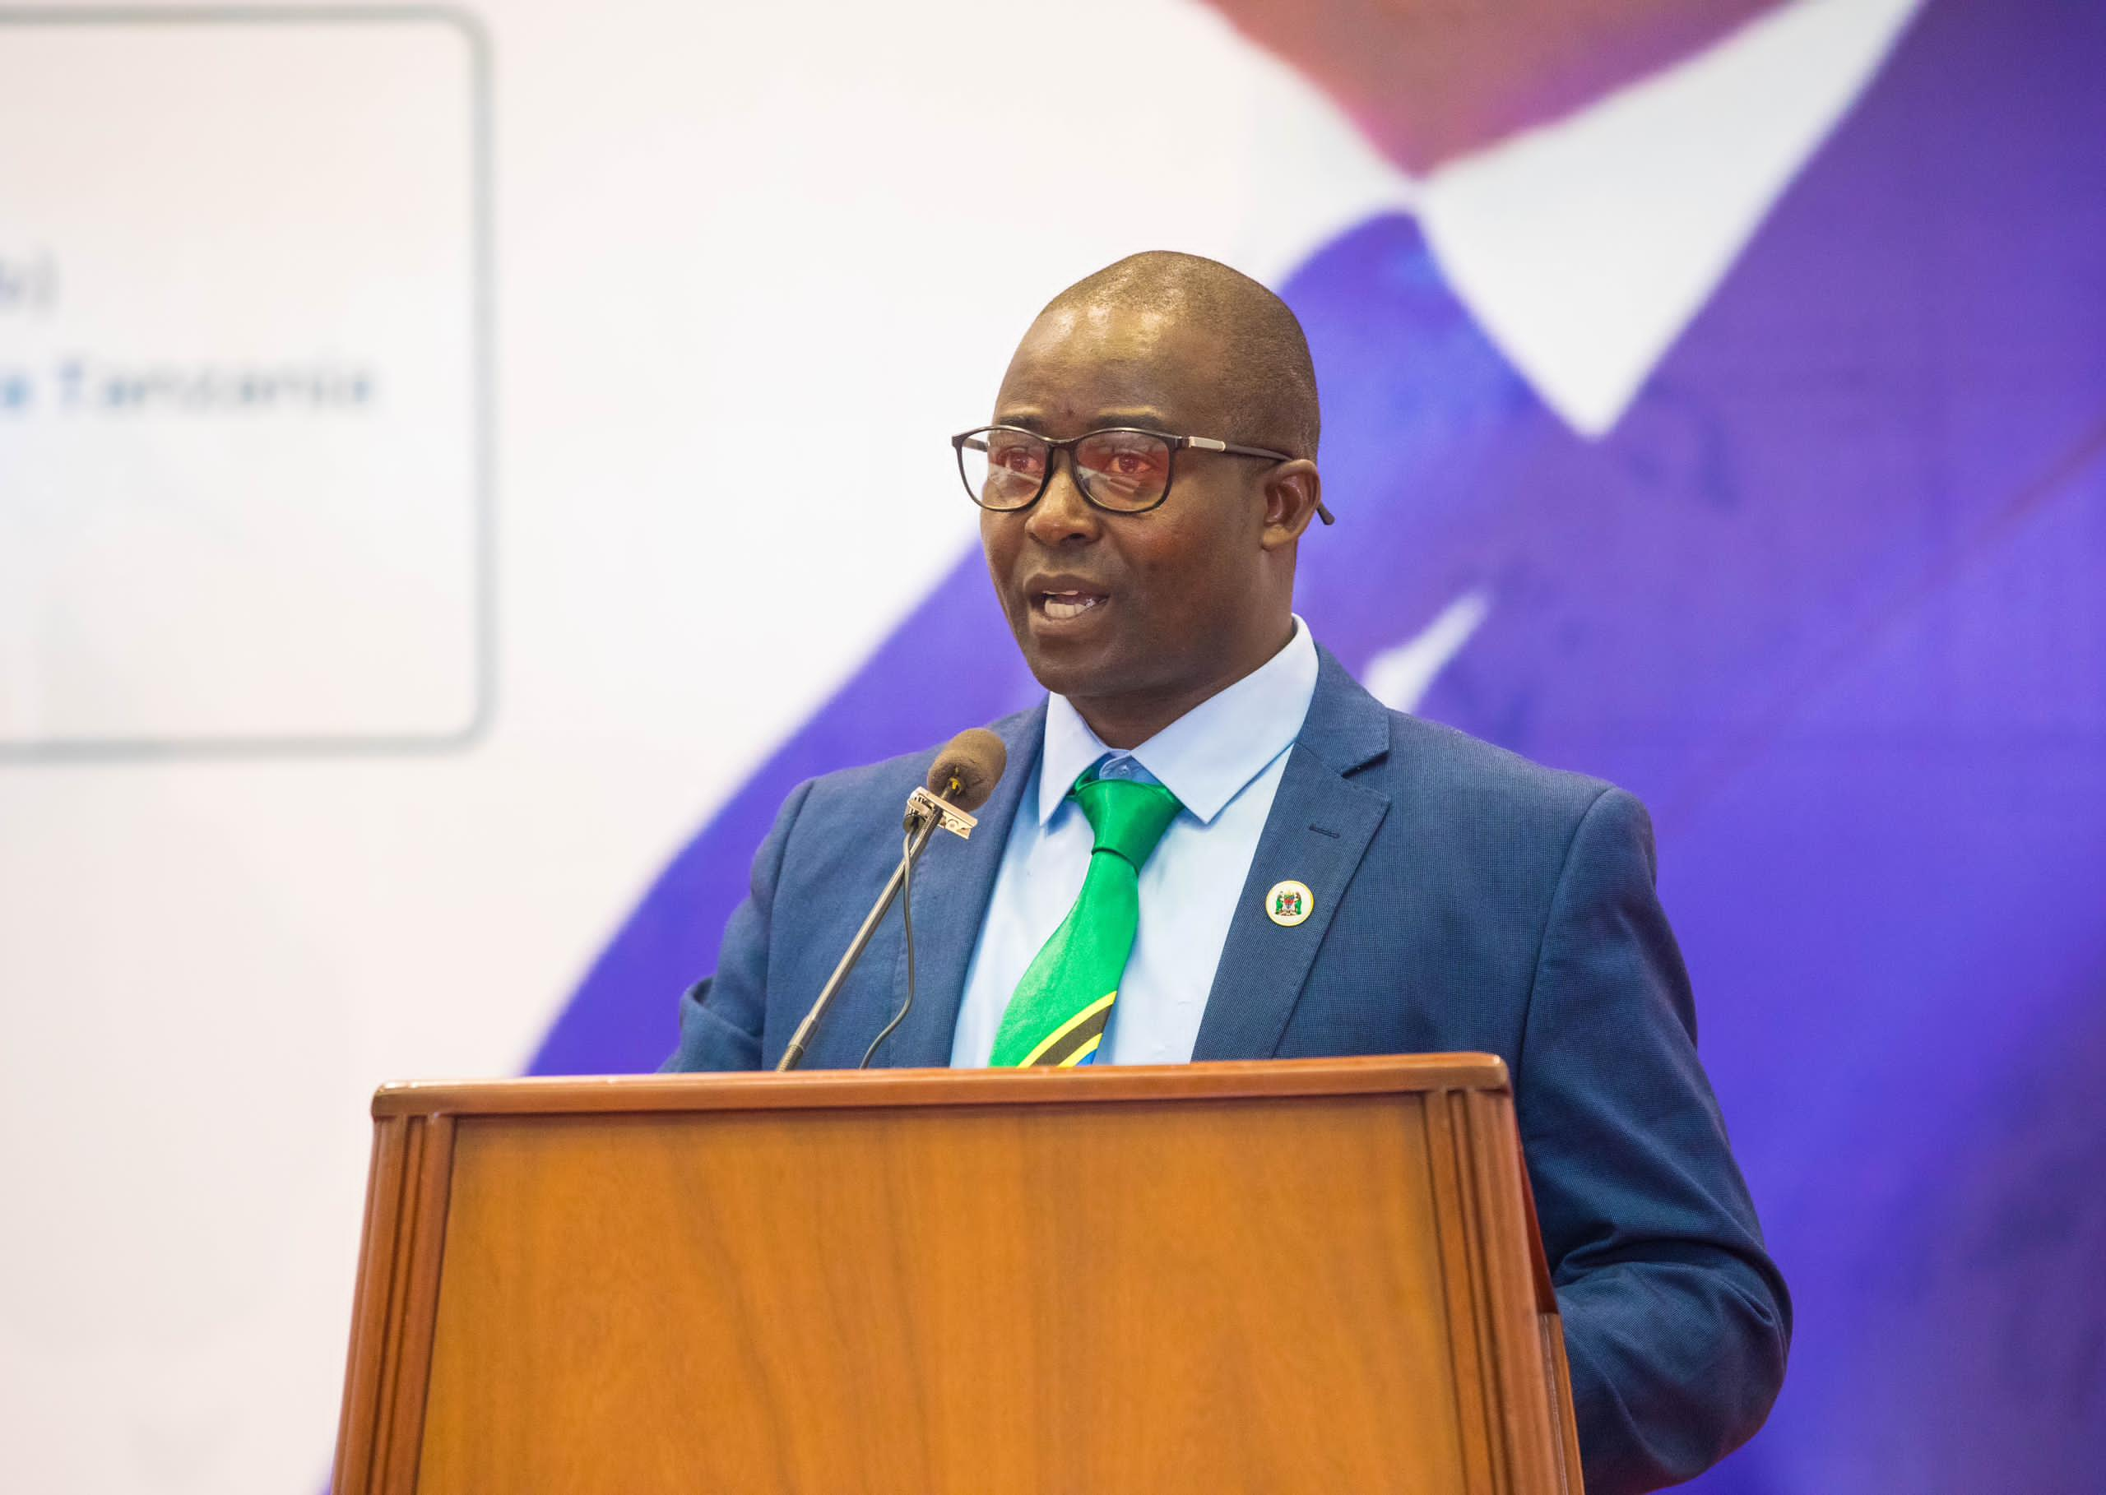
Mr. Deogratius Nsokolo, President UTPC

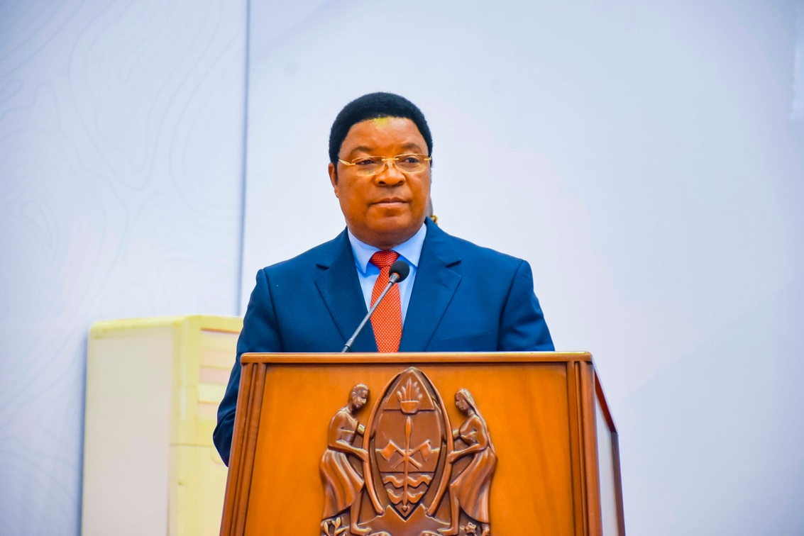
The Prime Minister of the United Republic of Tanzania, Majaliwa Kasim Majaliwa

1.2 Guest of Honour the Prime Minister Kassim Majaliwa Majaliwa
Opening the WPFD, the Prime Minister of the United Republic of Tanzania, Kassim Majliwa Majaliwa congratulated all media stakeholders for organizing the World Press Freedom Day for the year 2024 celebrations.

He said these celebrations provide opportunity to media stakeholders to discuss the state of the media in the country, along with discussing their responsibilities in promoting transparency, accountability, and democracy. Furthermore, these celebrations aim to foster understanding, knowledge, and cooperation between the Government, development partners, and civil society organisations.

He reminded that the importance of press freedom has remained strong as it was in December 1993 when the United Nations General Assembly declared the need for the world to commemorate this day in the broader context of promoting the freedom to seek, receive, and publish information in the public interest.

He commended this year’s theme for World Press Freedom Day; A Press for the Planet: Journalism in the face of the environmental crisis, because it reflects the current needs of society in addressing the challenge of climate change.

The Prime Minister said that the society recognises the importance of journalism not only in providing information, educating, and entertaining but also in ensuring the prosperity of democracy, good governance, and accountability in the country, not to mention environmental preservation for the benefit of the current and future generations.

He emphasized that this year’s theme addresses various human challenges, including climate change that does not accompany sustainable development. Given this theme, it is clear that we are holding these celebrations with a deep understanding of the crucial role of journalists in educating the public about the impacts of climate change. Additionally, it serves as a reminder to citizens of their duty in implementing strategies to combat these impacts.

​ 1.2.1 Fostering Media – Government Partnership

He recognised the power of the media in informing and educating the public about climate change, especially at this time when we are facing the clear threat of climate change and environmental destruction. Therefore, it is a noble duty of journalists to write in-depth stories about conservation and environmental issues.

He ​expounded the government's recognition and appreciation of the significant role of the media and its contribution to the development of our nation. He ​said this is due to the fact that through the media, the Government has been able to inform and educate the citizens about important issues and Government plans.

Majaliwa said the media ha​s significant contribution in promoting the participation and involvement of citizens in activities and implementation of Government plans, along with participation in important ​national campaigns. Also, the media have contributed to the maintenance and preservation of peace, unity, and national solidarity.

He confirmed that the Government has been committed and dedicated to protecting the rights of journalists and supporting the issue of press freedom in carrying out their daily duties.

He outlined the government's commitment to protecting and promoting press freedom in the country, including the establishment of the Ministry of Information, Communication, and Information Technology, which combines the tasks of journalism and Information and Communication Technology (ICT). This aligns with bringing together two authorities overseeing the media sector in the country, which are the Department of Information Services (Maelezo) overseeing print media, and the Tanzania Communications Regulatory Authority (TCRA), which oversees ​operations of the electronic media, including television and radio, as well as online media.

He mentioned other steps which demonstrate the commitment to promoting press freedom in the country, including the government amendment of the Media Services Act (MSA 2016), initiating the process of improving the 2003 Media and Broadcasting Policy to promote ethical journalism; having an informed society; the existence of press freedom; and robust management of the media sector enabled by modern technology for sustainable national development; laying solid foundations for freedom of expression, the right to access to information, and the responsibility to use that freedom.

Another step is preparing a National Communication Strategy to ensure stakeholders at all levels receive sufficient information and fully participate in national development and strengthening ​of Government communications.

Majaliwa also said that after the government heard the long-standing cry about the poor economic state of the media, it formed a committee to assess the status of journalists, performance, and media economics to ensure that the challenges facing the media and broadcasting sector are addressed collectively and extensively. This will contribute fully to bringing sustainable development to the sector itself and the community as a whole.

Other steps ​to enhance the media sector include increasing freedom of expression and opinion, which has benefited the media sector. The Government, in implementing press freedom practically, has reopened and issued new publishing licenses to some private newspapers that had been banned for a long time.

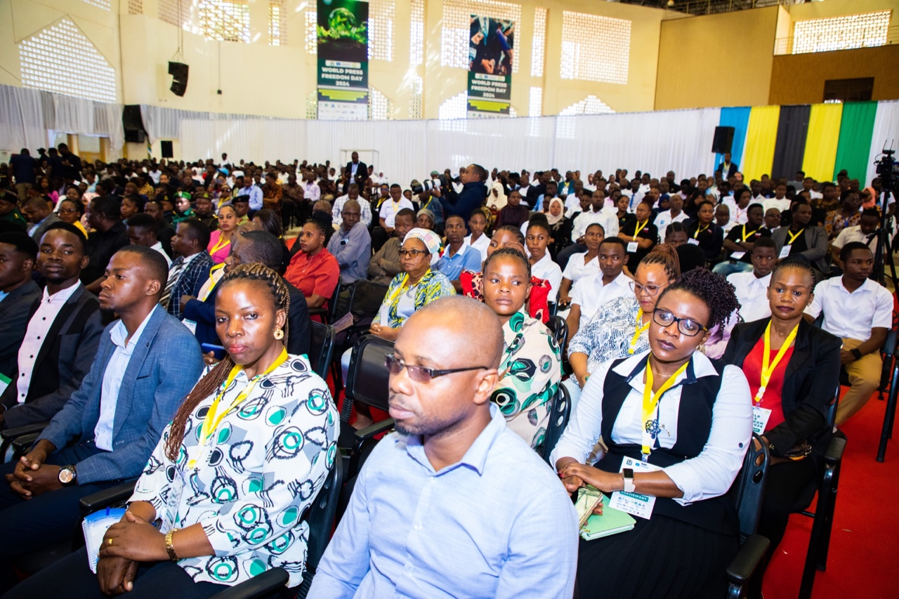
A cross section of participant of WPFD 2024

1.2.2 More efforts to Combat Climate Change

The Prime Minister emphasised that climate change challenges directly affect ecological systems, biodiversity, and human life. For instance, approximately 16 million people in Tanzania depend on coastal resources for their livelihoods, but at the same time, human activities negatively impact the health and systems of marine life.
He underscored that the increase in sea surface temperature causes drought, low rainfall, unpredictable seasons, and an increase in various diseases driven by climate change such as malaria.

The Prime Minister referred to the 2020 Energy Access Report, stating that more than fifty percent of households in the country still use firewood as the main source of cooking energy, while over twenty percent use charcoal. Due to this situation, the Government has put significant effort and deliberate measures to continue involving all stakeholders in promoting the use of clean and alternative energy.

However, he said that despite the importance and role of journalists in tackling climate change, there have been various challenges in writing and presenting news. Among them are the quality of the news written, with many being event-based rather than in-depth analyses.

Another challenge is that only a few media outlets and journalists in the country write in-depth stories about environmental issues. However, most of their stories focus more on biodiversity conservation, climate change, wildlife, tourism, or environmental news based on current events only.

The Prime Minister also said there are challenges in language, especially the use of foreign and scientific terms related to the environment; the limited understanding of journalists about scientific issues concerning the environment hinders their ability to write professionally.

He recalled the challenge brought by Artificial Intelligence (AI) technology due to its speed, as media find themselves being chased by these changes regarding integrity, accuracy, and skills in using this technology for professional benefit.

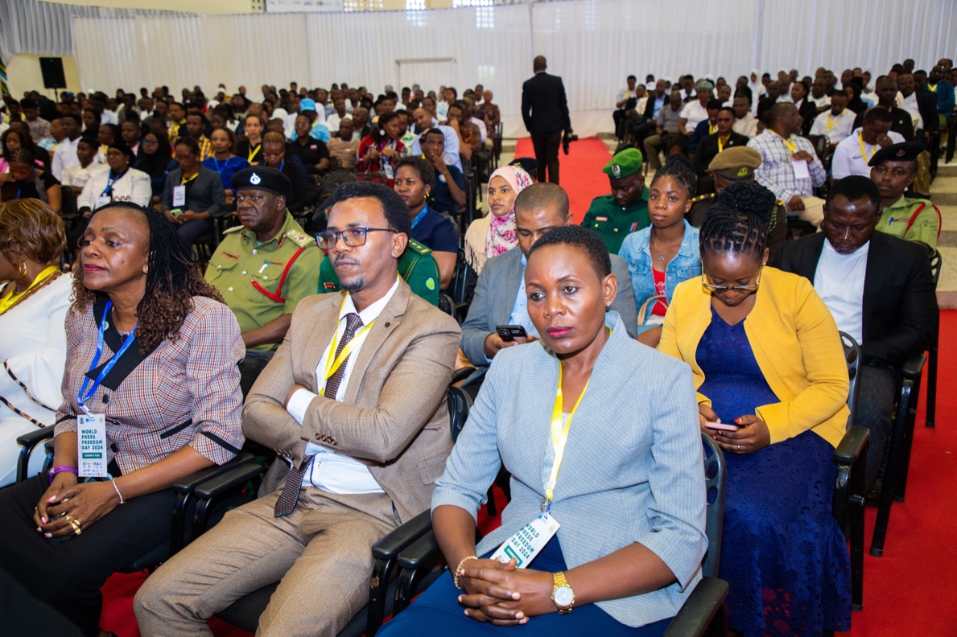
A cross section of WPFD 2024 participants

1.2.3 Journalists’ Safety and Protection Measures

He called for a specific plan to protect the safety of journalists and urged the stakeholders to cooperate with the Government to address challenges faced by journalists, such as arrests, illegal harassment, online attacks, travel restrictions, and challenges in accessing information. Efforts to solve these challenges should follow the good example of the dialogues held between the Union of Tanzania Press Clubs and the Tanzania Police Force regarding the protection and safety of journalists.

He urged journalists to use the existing challenges as opportunities as well as use the WPFD 2024 celebrations to discuss how to address these challenges in seeking, accessing, and obtaining reliable statistics.

He reminded leaders and Government officials and organizations to adhere to the 2016 Access to Information Act and urged them to remove bureaucracy in accessing information so that journalists can obtain accurate information and perform their duties efficiently.

He called on the Ministry of Information, Communication, and Information Technology to collaborate with relevant Ministries to develop a special plan to build the capacity and understanding of journalists on how to write news about climate change and natural disasters and process information in their respective media outlets.

Similarly, he urged media outlets to establish special desks to coordinate climate change issues. These desks should seek additional financial resources to implement a training plan for journalists on how to write professionally about climate change and its impacts on the community and the nation. This should be accomplished so that by next year's celebrations, there will be a report on the implementation.

1.3 Guest of Honor, Dr. Tulia Ackson Keynote Statement

The Speaker of United Republic of Tanzania Parliament, Dr. Tulia Ackson, expressed her gratitude for being invited to be the guest of honor at the opening of the WPFD 2024 commemoration. She said she had been informed that during the commemoration, stakeholders in the media sector would discuss, among other things, the safety and security of journalists, gender equality, technological and innovations, the economy of media, and legal and policy environment including working conditions.

1.3.1 Media and Climate Change
She reminded journalists to be cautious about issues of climate change and ordinary environmental issues, as there has been a tendency to mix the two. She urged journalists to learn and understand what climate change truly means. She gave an example of the recent floods in the Rufiji River area in the Coast Region. She explained that elders said such floods had occurred in the past, indicating that it is not a new phenomenon that can be directly linked to climate change. She noted that various studies in the country show that about 16 million people living in coastal areas depend on the resources in these areas, especially from the sea. She reminded that the habit of littering, especially plastic waste, affects the coastal environment and, thus, the lives of these people. She urged the media to be motivated to write about environmental protection to save the current and future generations from the damage caused by indiscriminate waste disposal.

1.3.2 On Gender-Based Violence
Dr. Tulia stated that among the discussions at the WPFD 2024 commemoration in Dodoma would be issues of gender-based violence and strategies to eradicate it. She reminded that when society talks about eradicating gender-based violence, it typically focuses on women and children. However, she noted that society has changed significantly, as men are also subjected to violence. Therefore, she urged journalists to recognise that the fight to eradicate gender-based violence against women and children should now also include men so that all groups are safe.

1.3.3 Media for Development
She acknowledged the role of the media and its contribution to societal and national development. She said that the media in the country is doing a good job of providing information about the development happening in the country. For example, she mentioned that the media has been reporting on progress in providing health services such as the construction of hospitals, health centers, and clinics, as well as developments in energy and water supply services. However, she said that although it is right for the media to report these achievements in detail, they also have a duty to be critical in highlighting the challenges associated with these developments. For example, she said it is good for the media to report on the state of service delivery at health centers. Are medicines available? Is the location of the center accessible? Overall, the media must show the impact of development projects, thereby fulfilling their duty by not just praising them.

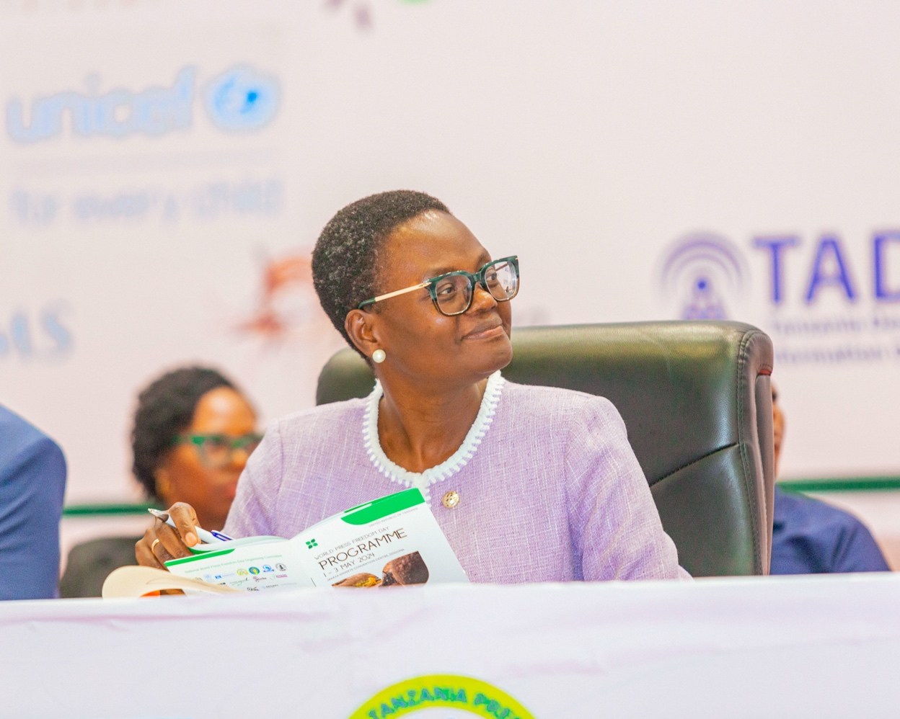
Speaker of the Parliament, Dr Tulia Ackson

1.3.4 On Media Freedom
She reminded that it is difficult for the media to be free if they do not have the economic strength to operate. She urged government institutions that owe media outlets to pay them so that from the improved economic situation they can fulfill their duties freely and efficiently. Dr. Tulia questioned the system of media outlets and how they operate. She challenged the practice where a media outlet is owned by one person, who is both a journalist and an editor, with no one else reviewing their work. She questioned how such an outlet can have the right to inform the public. She also asked how media outlets, especially those owned by individuals, separate personal opinions from news. She said that as the nation enters the local government elections this year and the General Election next year, it is crucial to ensure that media freedom is not violated by those who own media outlets as individuals who might decide to deal with candidates for personal reasons. She reminded that media freedom has its legal limits, just as an individual's freedom ends where another person's freedom begins. "Where your nose ends, your freedom ends because that is where someone else's freedom begins." Likewise, she reminded that in these times of Artificial Intelligence (AI), media outlets should be careful in using this technology, as it can be misused to intentionally harm others. She advised that news should be genuine news, not personal opinions.

1.3.5 On Bunge Reporting
Dr. Tulia expressed her desire for media outlets to start specialising in parliamentary reporting. She reminded that Parliament has been providing training to journalists on how to report parliamentary business, but due to the practice of frequently changing journalists, there have been challenges in developing expertise in reporting parliamentary news. She requested editors to start having dedicated, specialised reporters for parliamentary reporting.

1.3.6 On Media Laws
She stated that Parliament has the role of enacting laws and urged journalists to provide feedback on the use of enacted media laws if they are found lacking in promoting media freedom in the country. She promised that Parliament would receive and work on that feedback, but also noted that there is a parliamentary committee responsible for reviewing the regulations to ensure they align with the objectives of the relevant laws. She invited journalists to submit their recommendations on media laws and regulations so that the nation can have a conducive environment for media operations, as they have a significant duty to society. Finally, Dr. Tulia urged media outlets to be responsible in their operations, to inspire people where necessary, but also to criticise openly to build accountability.

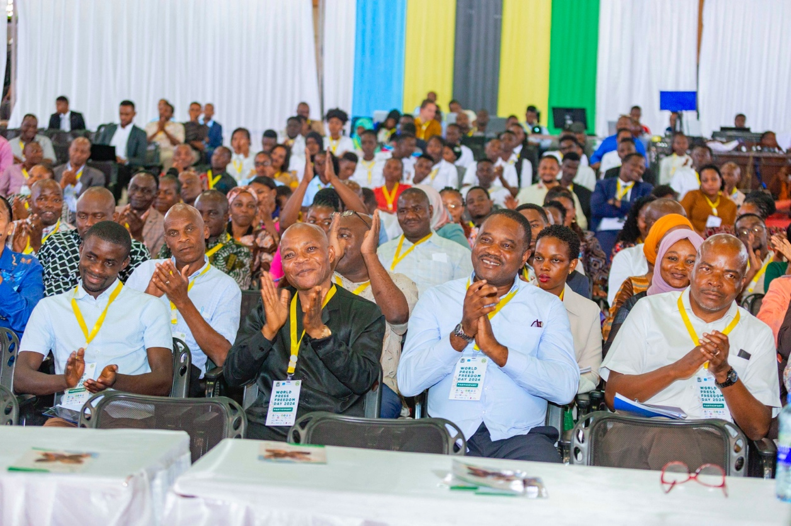
A cross section of WPFD 2024 participants

1.4 Statement by Minister for Information, Communication, and Information Technology

Minister for Information, Communication, and Information Technology, Nape Nnauye, thanked The Speaker of the United Republic of Tanzania Parliament, Dr. Tulia Ackson, for setting aside time to participate in the WPFD 2024 commemoration despite her busy schedule. He also thanked the organizers of the WPFD 2024 for their excellent work. He expressed gratitude to the President of the United Republic of Tanzania, Samia Suluhu Hassan, for her political will, which has facilitated many improvements in the media sector. He stated that although Tanzania has not yet reached the peak of press freedom, the current situation is better than before.

He thanked the media for continuing to maintain the country's peace and stability by setting the agenda for national development issues such as climate change and the use of clean energy. Nape thanked the Parliament for allowing the government to amend the MSA 2016, a process that involved media stakeholders in the country. However, he stated that the amendments are a compromise, as some sections cannot be amended until the media policy is revised.

He mentioned that the process of drafting a new media policy has begun. The goal is to have a new media policy that integrates all policies affecting the media sector, whether electronic or print media, into a single national media policy. He indicated that the government's intention after the policy is to consolidate all laws dealing with the media sector in the country in one legislation.

Nape acknowledged that the media sector faces significant economic challenges. He said that despite various policy and legal steps being taken in the country concerning the media industry, they will not be very beneficial to journalists being free if the economic condition of media outlets remains poor as it is now. He reminded that the practice of journalists being funded by news sources undermines and compromises the independence of journalists.

He confirmed that the government has received a report from the Commission established by the President's directives to look at the economic condition of media outlets. The current task is to analyse the relevant recommendations before making decisions.

He reminded media outlets to treat all political parties and candidates fairly in the upcoming local government elections later this year and the General Election in 2025. However, he urged wisdom in reporting election news by adhering to journalistic ethics and standards to help build true democracy in the country.

He concluded by the following quote: "Freedom of the press is not just important to democracy, it is democracy."
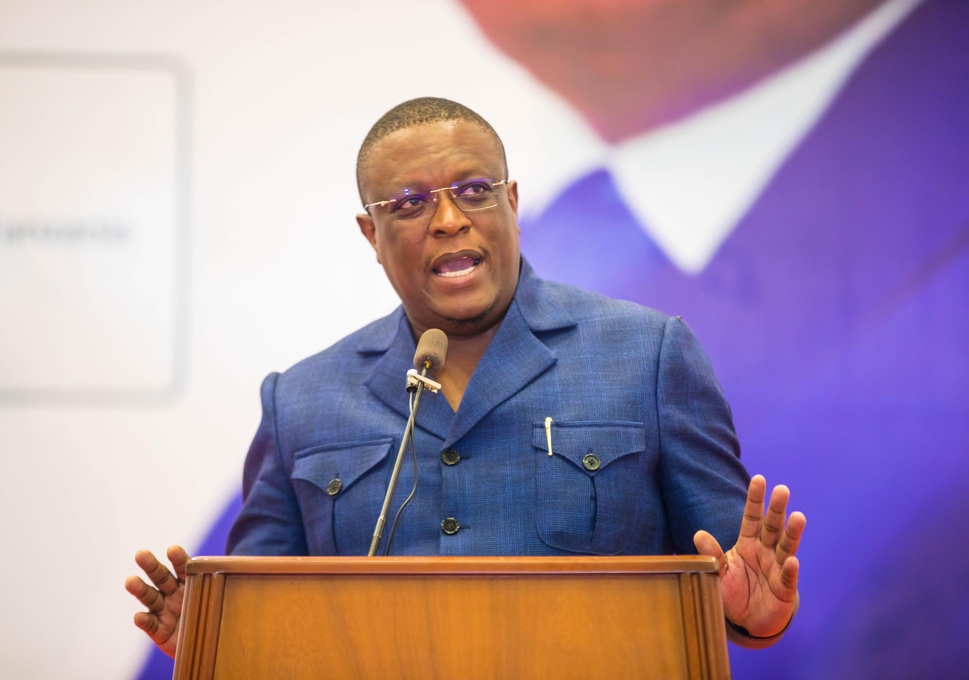
Minister for Information, Communication, and Information Technology, Nape Nnauye

1.5 A Message by Michel Toto, Unesco Representative
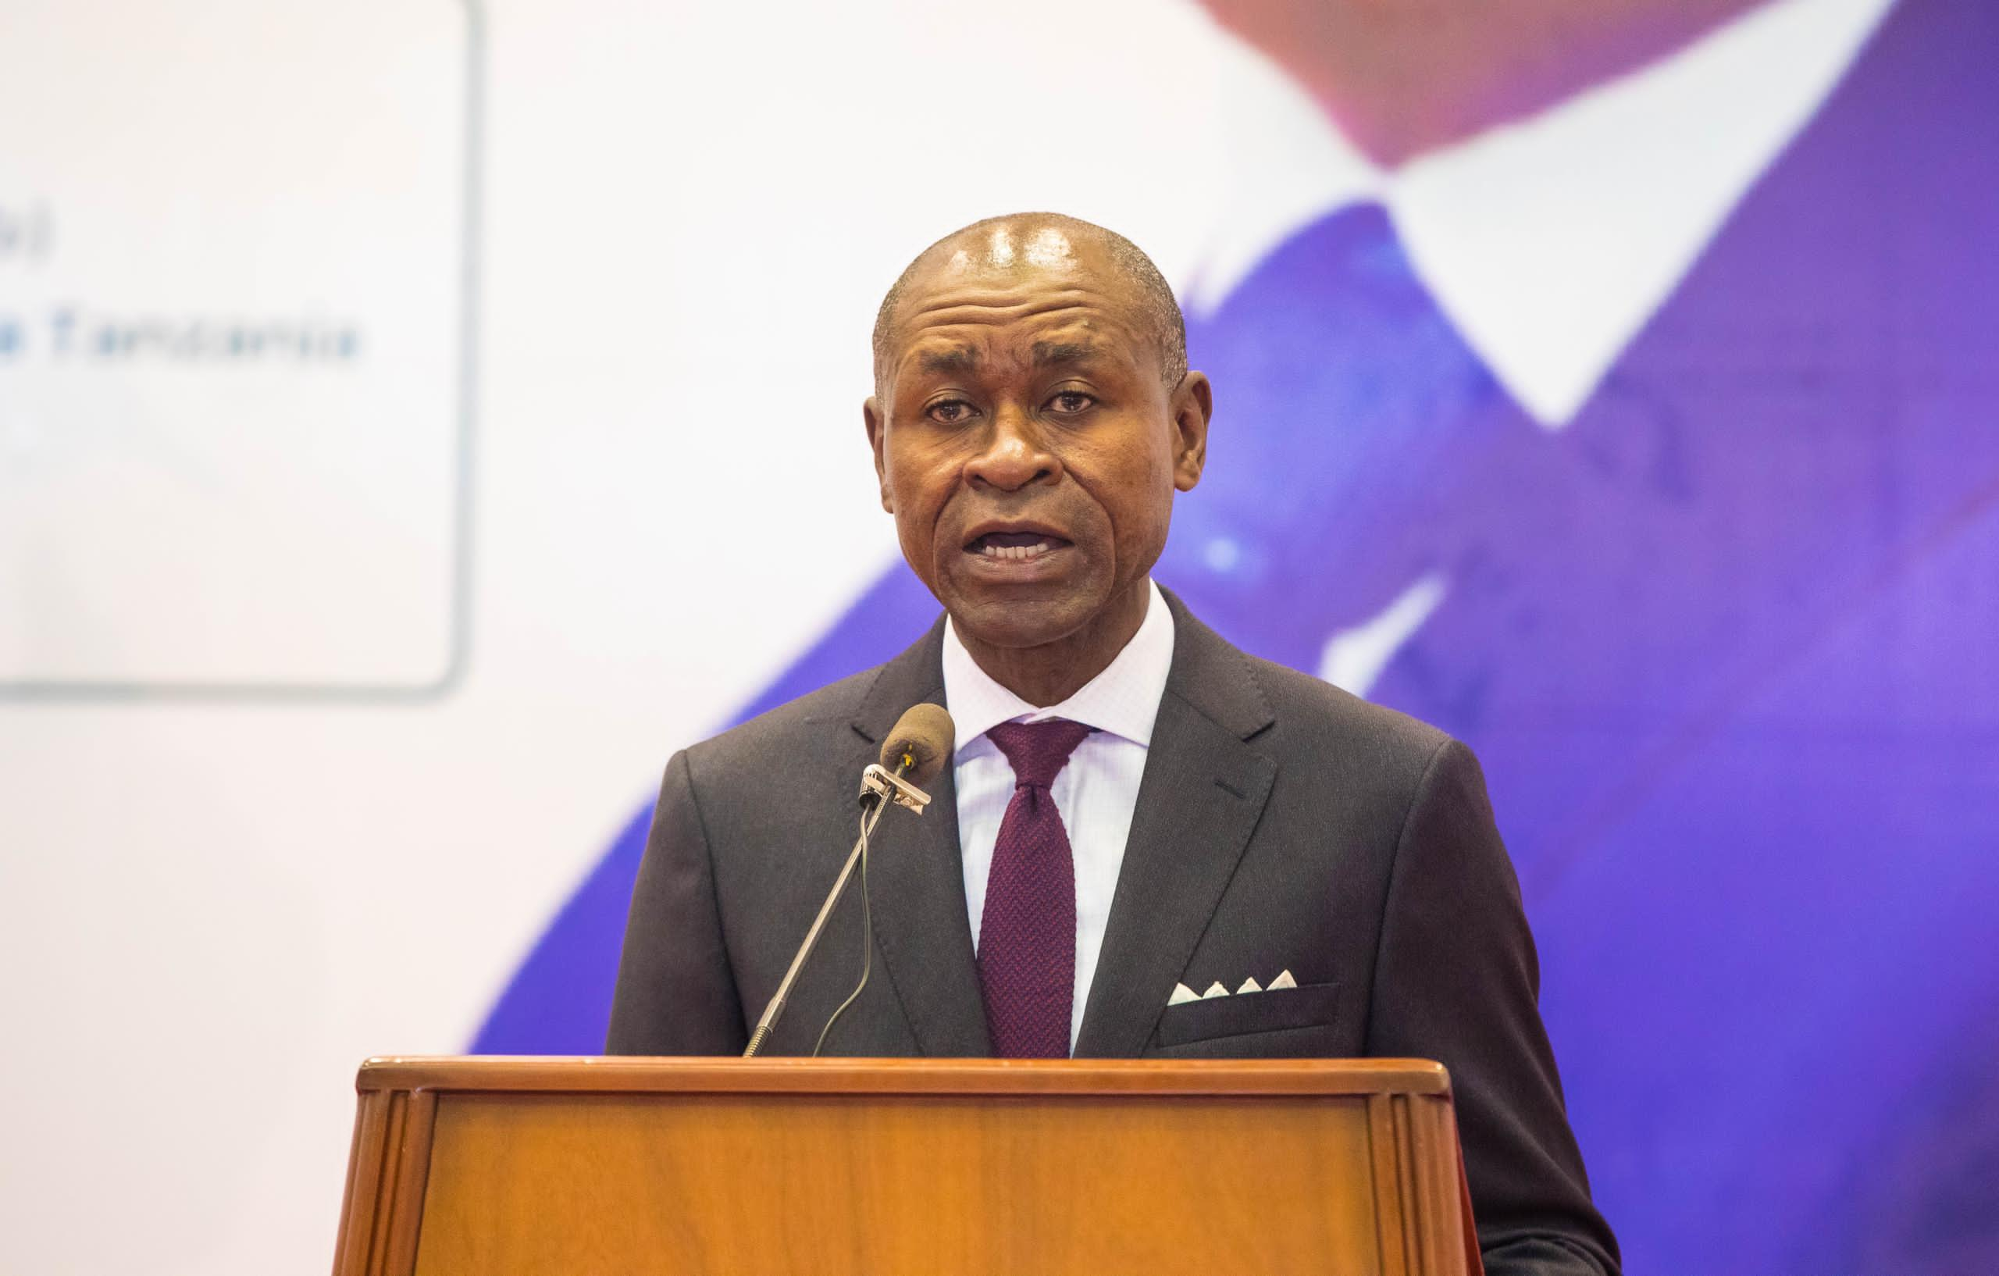
Michel Toto, Unesco Representative

He reminded the critical role that a free and independent press plays in upholding democracy, fostering transparency, and promoting accountability, that is why Unesco is emphasising on the importance of defending and protecting press freedom as a fundamental human right. He underscored that the freedom of the press is not a privilege but a key pillar of democracy, enabling the public to access information, express themselves, and engage in informed debates on issues that shape our society.

1.5.1 On Digital Challenges
He said that in a contemporary world we are in with ever-evolving digital age, the press faces new challenges and threats, including misinformation, censorship, and attacks on journalists. He urged all stakeholders to work together to create an enabling environment that safeguards journalists' safety, ensures media pluralism, and upholds freedom of expression for all. He committed to fostering safe digital spaces for all individuals in Tanzania. This includes addressing the issue of Online Gender-Based Violence (OGBV), with a specific focus on empowering women in politics and the media sphere.

1. 5.2 Commend Parliament
He appreciated the Parliament's efforts in advancing a progressive and sustainable media landscape that not only enhances democracy but also contributes to advancing national development goals in Tanzania. He further commended some positive strides, such as amendments to media laws and the implementation of new regulations aimed at enhancing the media environment.

However, he said there is still much ground to cover, to propel Tanzania to the forefront of rankings in media freedom and press freedom. He reaffirmed UNESCO's willingness to continue supporting the Parliament, the Government, and the media community, including supporting and empowering journalists, media workers, and media organisations, to meet these targets.

1.5.3 Inclusivity and sustainability
He took cognizant of the theme of this year's World Press Freedom Day, “A Press for the Planet: Journalism in the face of the Environmental Crisis," by asking all media stakeholders to reflect on the importance of quality journalism, ethical reporting, and media literacy in building a more inclusive and sustainable world. He challenged government officials, lawmakers, civil society, and the media industry to work hand in hand to create a safe and conducive environment for journalists to fulfil their essential role without fear or favour. His call was for all to stand together to support and protect the work of journalists.

He urged all to celebrate the power of journalism to inform, inspire, and drive positive change in the face of the global environmental crisis. He was convinced that together, Tanzania can harness the transformative potential of a free press to create a more resilient, equitable, and sustainable world for generations to come.

1.6 A Message by Zlatan Milisic, UN Resident Coordinator
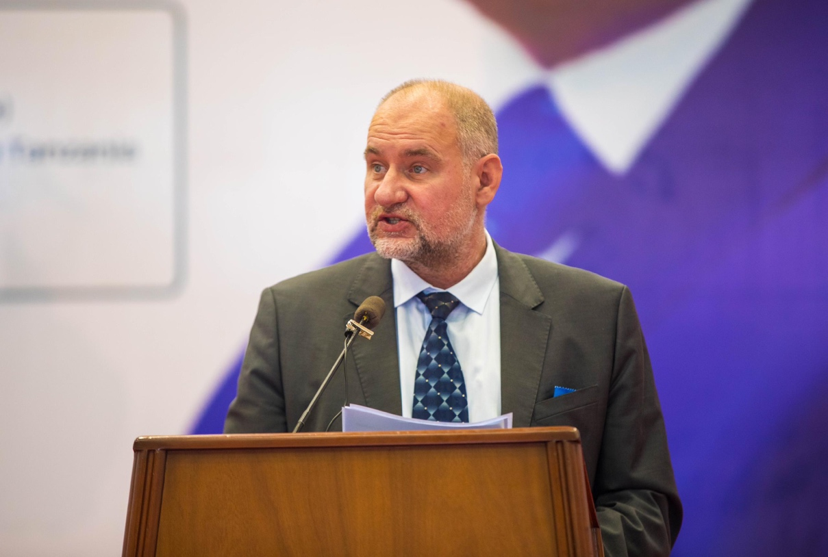
Zlatan Milisic, UNRC

He pointed out the relevance of commemorating the World Press Freedom Day, as a day that compels all media stakeholders to reflect on the vital principles of press freedom, to assess its global situation, and reaffirm collective commitment to defending the media. As well, he reminded that the occasion serves as an expressive reminder of the risks journalists face; many have suffered harm or lost their lives in the pursuit of their profession.

Commenting on this year’s theme, "A Press for the Planet: Journalism in the face of the environmental crisis," he stated that it highlights the critical role of the press in addressing environmental degradation, underscoring its profound connection to human rights. The right to freedom of expression, as enshrined in Article 19 of the Universal Declaration of Human Rights, is fundamental to the enjoyment of all other human rights.

Milisic recognised the Tanzania's rich biodiversity and ecosystems which provide a fitting backdrop for the WPFD 2024 theme. He emphasised the fact that the environmental crises we face today transcend borders and demand a unified, informed response, a task where the press plays an indispensable role.

He made a special reference to the recent times, from the COVID-19 pandemic to elections and climate challenge, the value of press freedom in upholding human rights and the consequences of its restriction have become ever more apparent. That the need for accurate, timely, and independent journalism has never been more critical.

1.6.1 On Media and Environment
Also, he said it is worth recalling that environmental crises pose existential threats not only to our ecosystems but to human health, livelihoods, and security. That journalism serves as a crucial conduit for information, empowering individuals with the knowledge to advocate for sustainable and equitable policies. This sharing of information is foundational to resilience and democratic governance.

It is in this regards the United Nations in Tanzania recognises the importance of access to information as a public good. He commended the Government of Tanzania for its efforts to open and strengthen civic and media space. Nevertheless, he encouraged the continuation of improvements to the legal, regulatory, and operational environment for media development and freedom of expression.

He reminded that the UN Special Rapporteur on the promotion and protection of the right to freedom of opinion and expression plays a vital role in upholding press freedom globally. Thus, he reaffirmed their commitment to supporting this mandate and addressing the challenges that impede progress.

Furthermore, he asserted that in their collective quest to protect and sustain our planet, the UN Cooperation Framework (UNSDCF) has strategically prioritised environmental sustainability as a core pillar. He explained that this commitment is manifested in their dedicated efforts to create enabling environments and enhance the capabilities of both duty-bearers and rights-holders. Central to this initiative is UNESCO, the UN agency with a specific mandate to promote freedom of expression, access to information, and media development across digital and traditional platforms.

He was optimistic to the Summit of the Future, a global summit taking place at the UN General Assembly in New York later this year, arguing that the narrative shaped by journalists will significantly influence the discussions and resolutions. The media role in disseminating knowledge and fostering a culture of accountability ensures that environmental sustainability remains at the forefront of national priorities.

Furthermore, he pledged to enhance the conditions under which journalists operate, advocating for policies that safeguard freedom of information and support a free press. He said this is not merely foundational to democracy, but more significant a crucial for effective environmental stewardship.

He acknowledged the role media is playing at local level and in global stage, as press reflects the current realities and guides global community towards a sustainable future. He emphasised that the narratives crafted by journalists spur community action, shape public policy, inspire collective environmental responsibility.

1.6.2 A leaf from the United Nations Secretary General, Antonio Guterres
Milisic made a reference to the WPFD 2024 special message from UNSG Guterres as follows: -

“The world is going through an unprecedented environmental emergency which poses an existential threat to this and future generations. People need to know about this – and journalists and media workers have a key role in informing and educating them.

“The United Nations recognises the invaluable work of journalists and media professionals to ensure that the public is informed and engaged.

“Without facts, we cannot fight misinformation and disinformation. Without accountability, we will not have strong policies in place. Without press freedom, we won't have any freedom. A free press is not a choice, but a necessity.

“I call on governments, the private sector and civil society to join us in reaffirming our commitment to safeguarding press freedom and the rights of journalists and media professionals around the world.”

1.7 A statement by the US Ambassador, Michael Battle

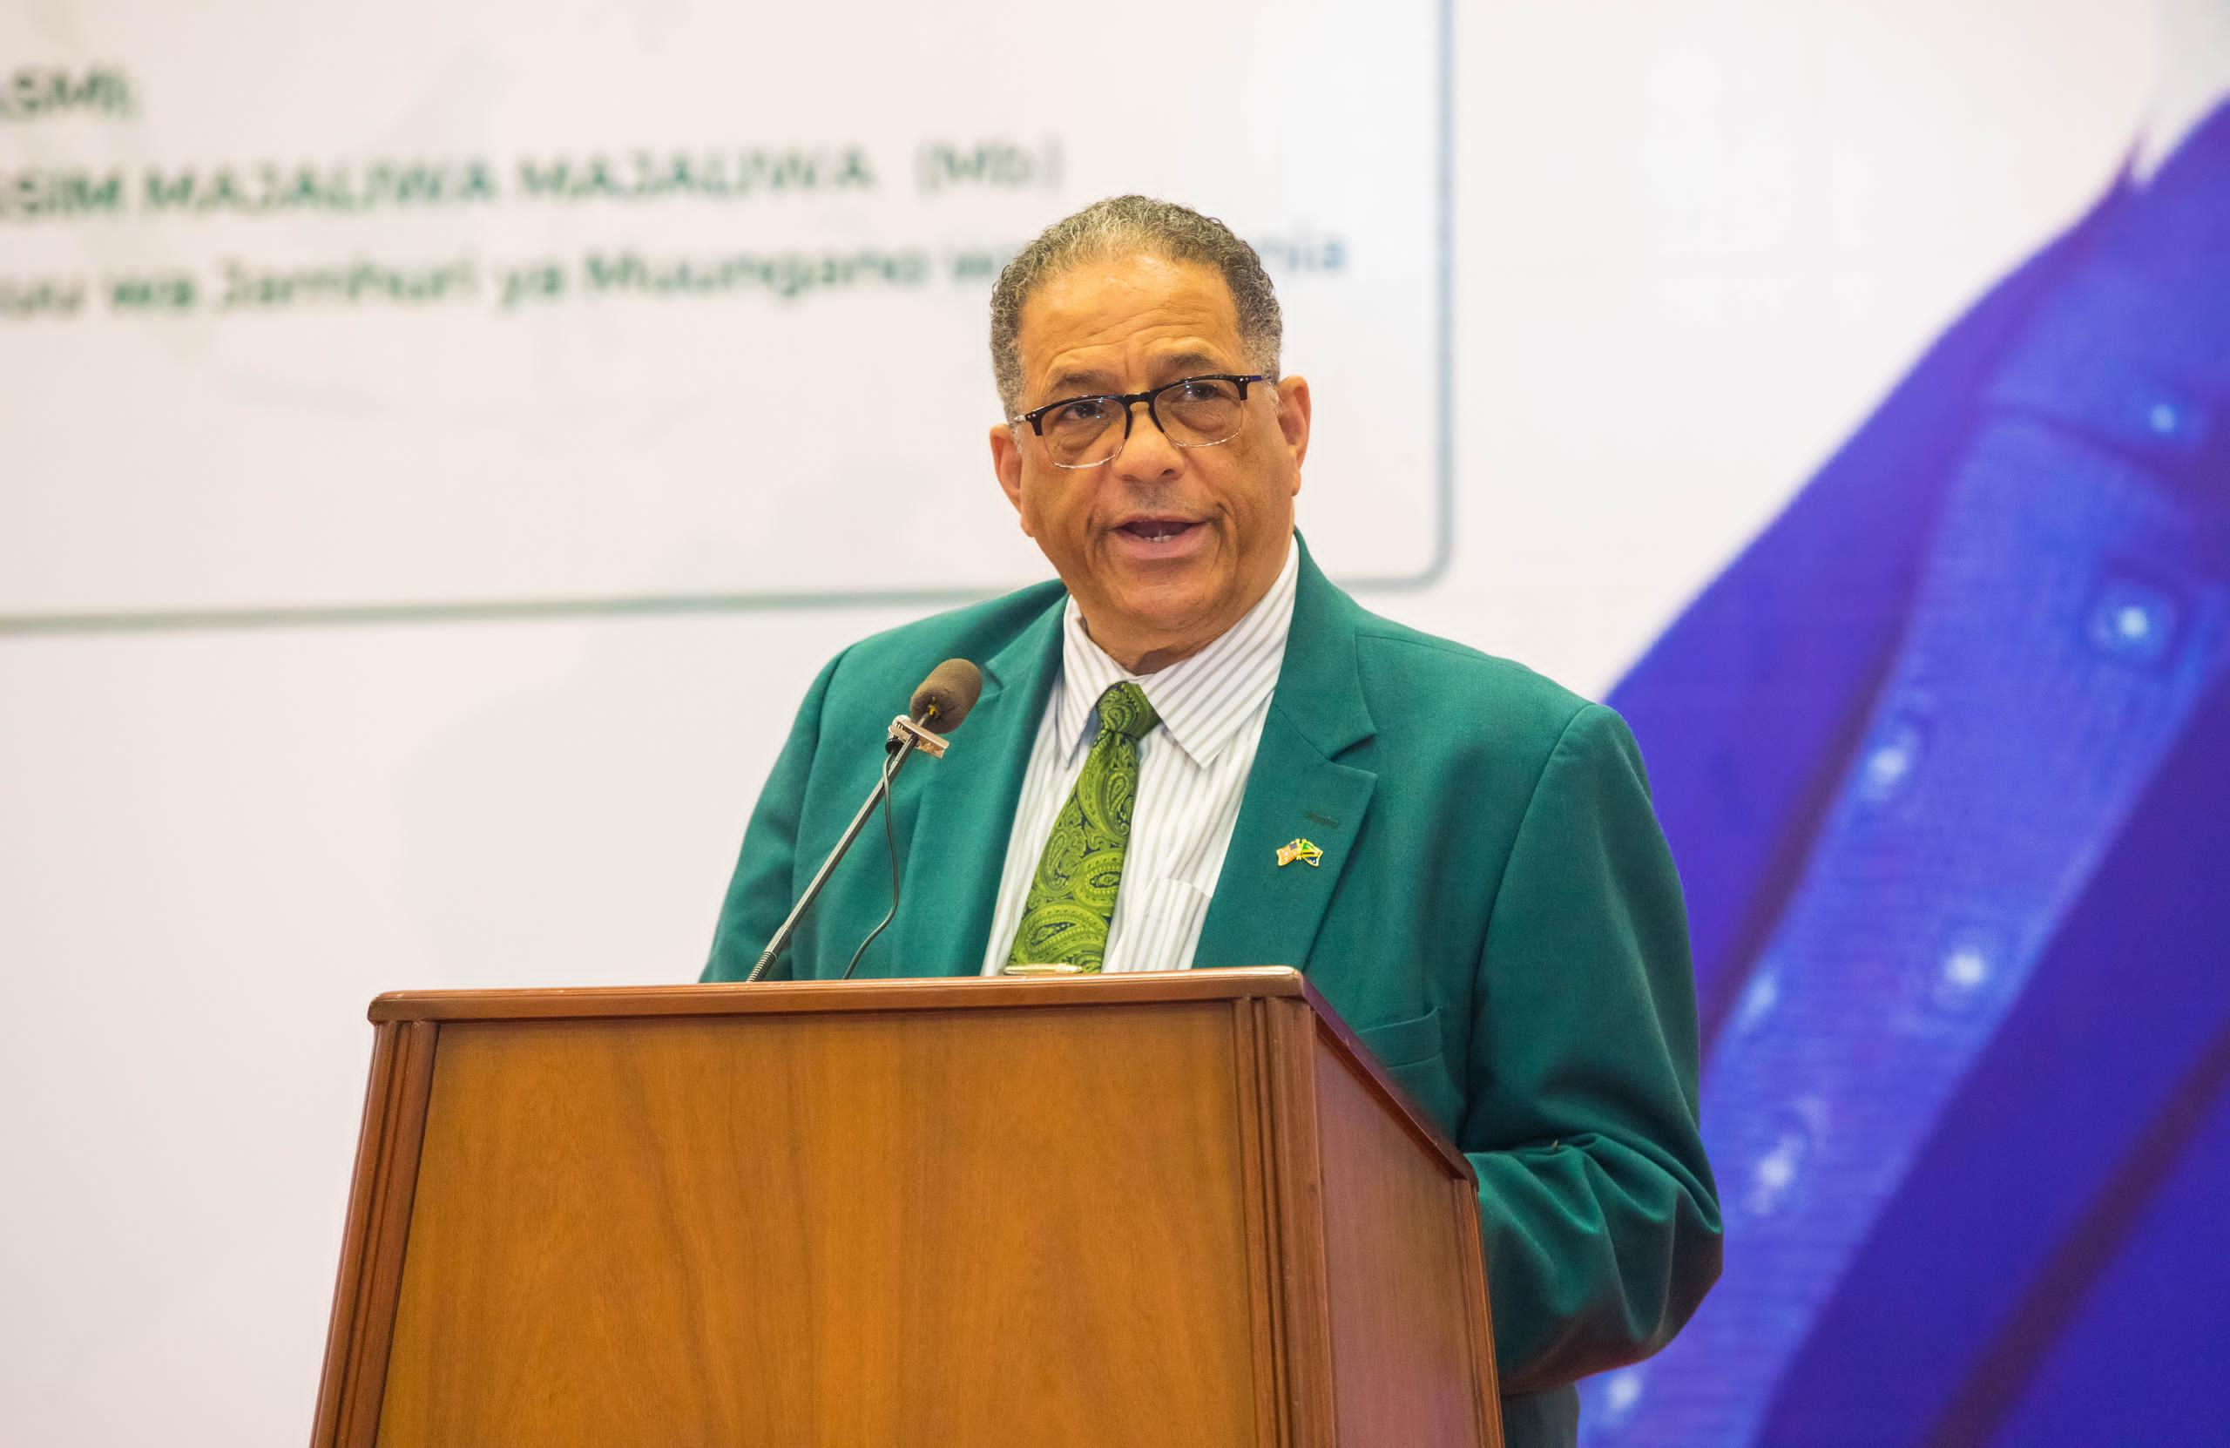
The US Ambassador Michael Battle

He was delighted to see Tanzania media stakeholders - the government, UNESCO, and other media organisations led by the Union of Tanzanian Press Clubs, collectively joined in the momentous occasion of commemorating the 2024 World Press Freedom Day.

He underscored that freedom of the press is a basic prerequisite to freedom for the people. Therefore, a free press is the oxygen of a healthy democracy. He noted that in this age of misinformation and disinformation, the onus has never been more on the public to verify their news sources and to make sure media houses earn the public trust through truthful and responsible reporting.
Ambassador Battle reiterated the fact that press freedom fosters an informed citizenry, and an informed citizenry can make informed decisions on the best direction for its people. Furthermore, an informed citizenry can make informed decisions on who is best suited to lead them.

1.7.1 Journalists in the Right TrajectoryHe attested that since coming to Tanzania, has been impressed with the wide variety of journalists he has engaged with. He cited the citizen journalists that he has met at the Jamii Forums Storytellers of Change gala, to the professional journalists at national outlets who he had the pleasure to interview with, he commended them for the work they do to advance Tanzania’s democracy.

He acknowledged the work of journalists which collectively have combated ignorance and educated the public. He underscored that quality journalism depends heavily on quality information, while open data is the foundation of a free press.

Ambassador Battle proudly took part in the 2024 WPFD commemoration to announce the publishing of a report by AidData, a data research lab at the College of William & Mary in Virginia, assessing the value of the U.S.-Tanzanian relationship in the lives of everyday citizens.

He pointed out that AidData’s mission is to advance the cause of data transparency, enabling journalists to accurately assess the value of development dollars. By using this data, Tanzanians can assess for themselves, how countries like the U.S. are contributing to their development, and then make informed choices on how best to partner.

He highlighted few findings by AidData, as the U.S. contributes $2.8 billion annually to Tanzania’s development. Another significant finding is the Tanzanian diaspora who have been welcomed to live, work and study in the U.S. contributes an additional $96.4 million. He then encouraged Tanzanians to check out their full report, which can be accessed on AidData website.

As well, highlighted some work that have been achieved through their flagship health partnership, PEPFAR, which has spent 20 years investing in strengthening health infrastructure, and tackling the HIV/AIDS pandemic. As a result, some 750,000 Tanzanians have been saved from premature death from this deadly disease. Through USAID, the Center for Disease Control and Prevention, and Walter Reed Army Institute for Research US is directly contributing to the strengthening of Tanzania’s health systems, laboratories, and overall health.

He emphasised that the U.S. government supports Tanzania’s growth and prosperity in three ways: (1) bilateral assistance, (2) multilateral assistance, and (3) creating a favourable policy environment to facilitate trade, immigration, and investment. He demonstrated that US is committed to contributing to Tanzania’s prosperity. He made a reference to the U.S. Vice President Kamala Harris visited in April 2023, when she committed 560 million U.S. dollars in bilateral assistance for 2024.

Other areas of interests between Tanzania and the US are then opening of Commercial Dialogue pursuing four mutual priorities: the digital economy, market access, regulatory and business climate reform, and trade missions and trade fairs. In the Millennium Challenge Corporation – a U.S. government agency that provides grants to promote economic growth and strengthen institutions – announced in December 2023 that Tanzania had been selected for a Threshold Program.

He proudly announced that it is estimated that U.S. government-driven assistance contributes roughly one billion U.S. dollars annually to Tanzania’s economy. And this is government, which does not even scratch the surface of our vast people-to-people ties - the American private sector, universities, foundations, charities, non-governmental organizations, and individual citizen’s partner with Tanzanians every day.

1.7.2 On Investigative Journalism and Press Freedom
He reiterated that using open data, AidData has done the work of quantifying the impact of the US work in Tanzania. Open data is a prerequisite for investigative journalism, and for the further advancement of democracy in Tanzania.

The Ambassador US is heartened by the steps the President Samia Suluhu Hassan and her administration have taken to deepen democracy in Tanzania, and to strengthen Tanzania’s economic partnership with the United States and others. They are excited to continue to work with Tanzanians across government and civil society to make that vision more of a reality for all Tanzanians.

He said that the US is joining other people across the world, to call for the defending the freedom of the press, and supporting informed citizenries across the globe.

1.8 Remarks by Switzerland Ambassador Didier Chassot

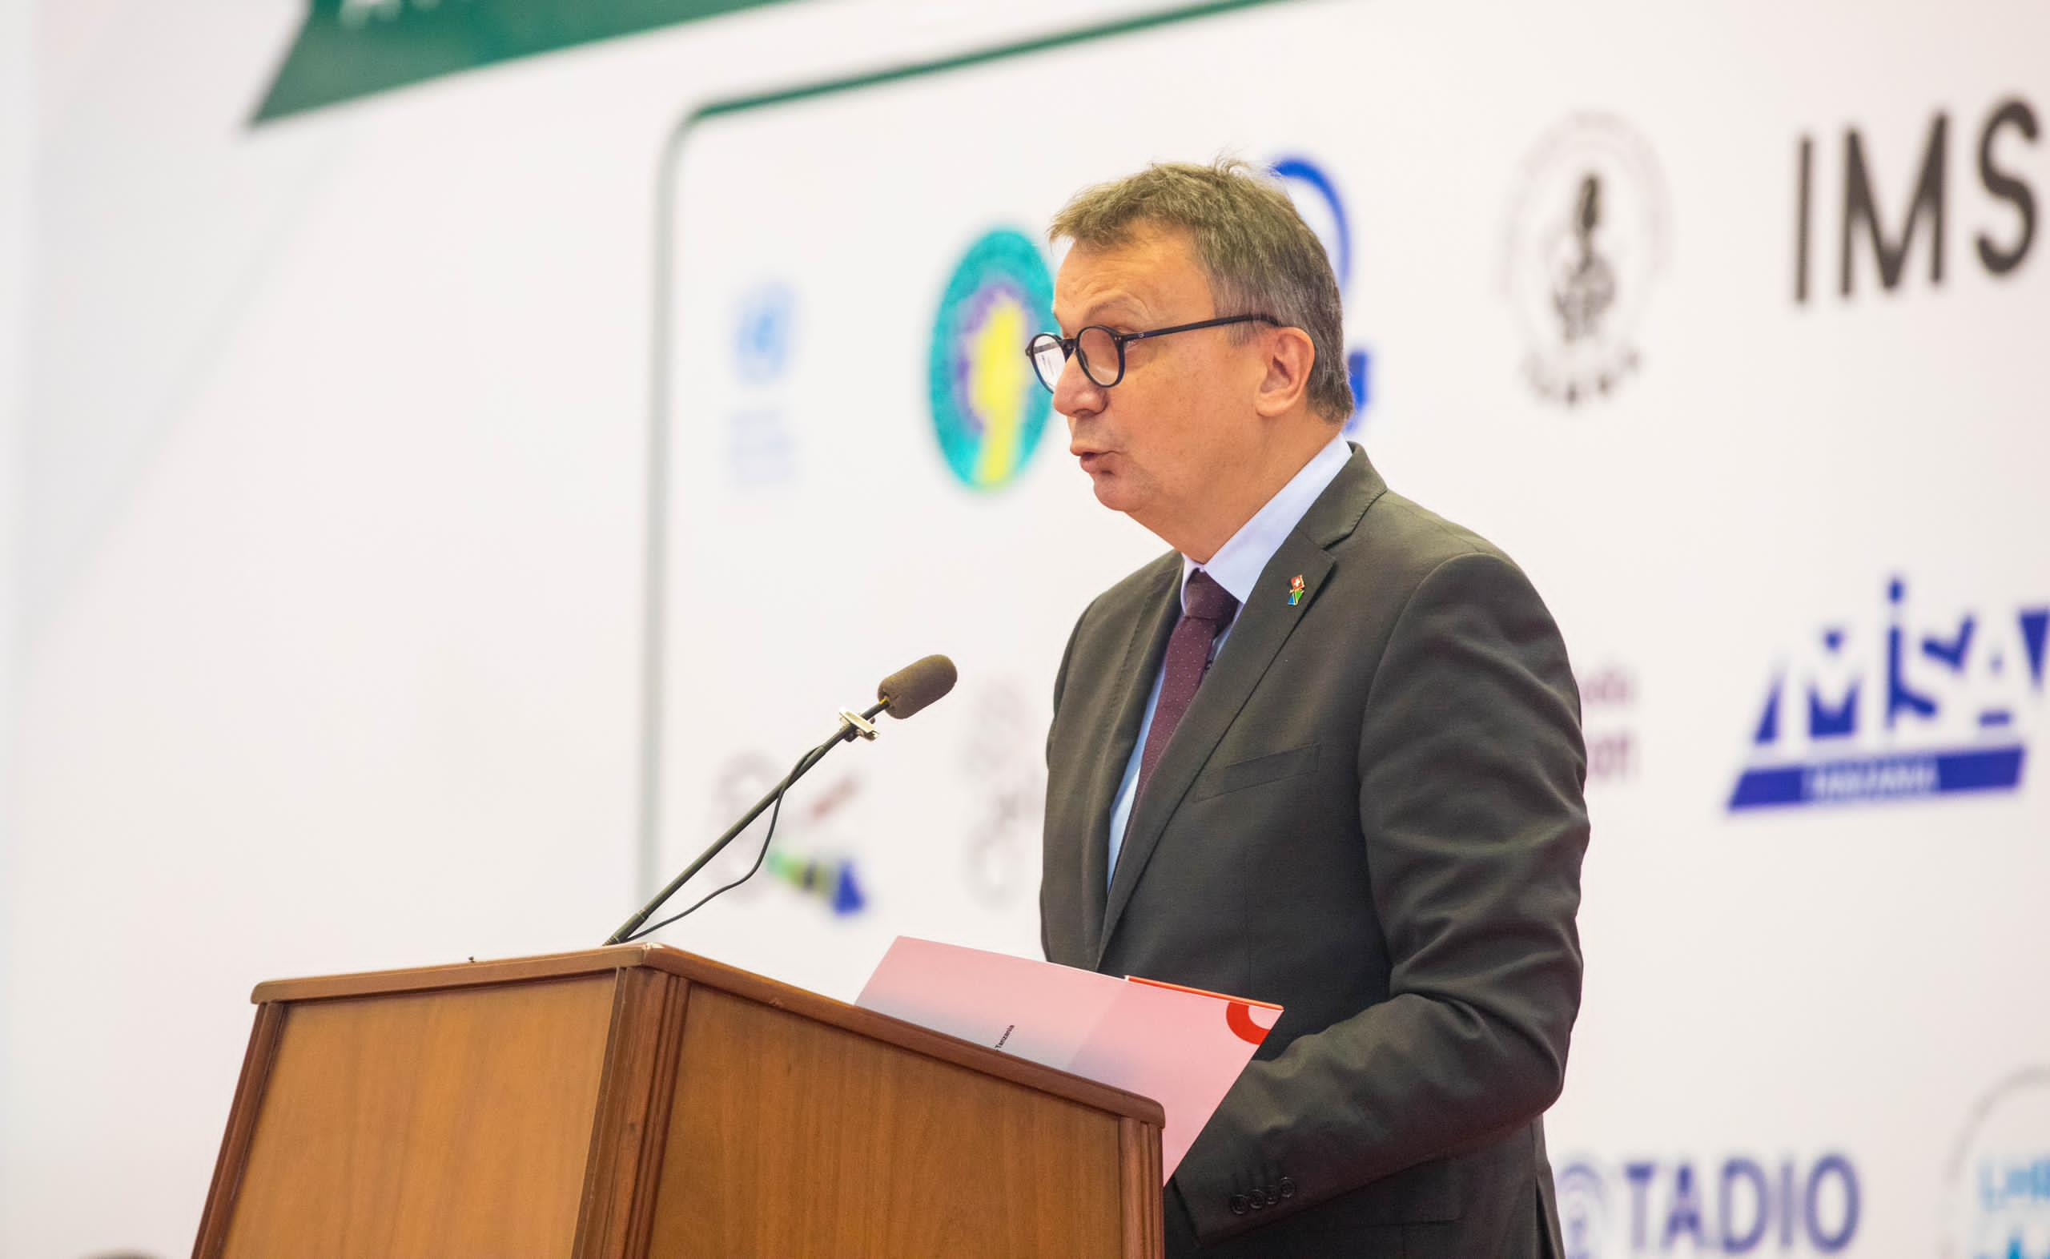
Switzerland Ambassador Didier Chassot

He expressed his heartfelt appreciation for the organisers of 2024 WPFD which was led by UTPC, as well the invitation that has been extended to him to be part of people commemorating 2024 WPFD which came again after the one happened in Zanzibar in 2023.

Ambassador Chassot gave an account of Switzerland as a longstanding supporter of the media in Tanzania as they believe that the media is the lifeblood of a functioning democratic society.

In particular, he recalled that over the past four years Swiss have partnered with International Media Support and through them UTPC and a number of local actors to support safety of journalists. He explained that they work with the BBC Media Action to promote gender equality and support financial viability of rural radios across the country.

Swiss as well contributes to the University of Dar es Salaam’s School of Journalism and Mass Communication who produces the annual Yearbook on Media Quality, a vital resource for media stakeholders to reflect on the performance of the media sector in Tanzania. Also, worked with Jamii Media to support online media, particularly those owned by female journalists, and they have partnered with Internews to promote media viability.

Reflecting on last year’s commemoration in Zanzibar, he said that was reminded of the government's pledge, from both the mainland and Zanzibar, to improve media laws, a commitment that was met with both hope and anticipation. In Tanzania mainland the bill was in parliament while in Zanzibar the conference was informed that the new Media Services Bill would go to the House of Representatives soon and that it was ‘80% done’.

1.8.1 Acknowledge Progress in Legal Environment
He said it is encouraging that as Tanzania media stakeholders meet in Dodoma, a year later, significant progress has been made. The amendment of the Media Services Act, for Tanzania mainland, which now includes provisions for social security and insurance for media professionals, marks a positive step forward in enhancing media freedom and protecting journalists’ rights. There are also ongoing efforts to review the media policy.

However, he advised that while the media fraternity is celebrating these achievements, it must also be recognised that the journey is not over yet. Indeed – of the 21 recommendations put forth by stakeholders to the parliament on the mainland to improve media legislation and practice, only eight have been implemented. Furthermore, in Zanzibar, the promise to pass a new media law remains unfulfilled. On the other hand, the media also need to acknowledge that newsrooms need to improve, especially for female journalists.

He was cognisant of a report by the Tanzania Media Women Association (TAMWA) which was released in November last year, that looked at sexual harassment in the newsroom, found that 77% of respondents reported experiencing sexual harassment within their respective media outlets. While it is imperative to engaging authorities to improve legislation, there is also a need to focus in improving the situation in the newsroom. Media managers, for instance, need to be first respondents in cases of emergency.

1.8.2 On Press Freedom Violation
Furthermore, he noted the continuation of the incidents of press freedom violations. Acknowledging organisations like UTPC and the Media Council of Tanzania efforts in recording these incidents, the cases that were recorded in 2023 have included arrests and detentions, denials of access to information or access to sources or stories, assault and threats.

He said that the backdrop highlights the need for continued advocacy and multistakeholder dialogue to ensure a shared understanding of the vital role that the media plays in the society and the need to support the media so that it effectively fulfils this role.

1.8.3 Media and Climate Change
On the 2024 WPFD theme he emphasised how a free and independent media is essential in the ongoing fight to mitigate climate change and environment risks.

He underscored that reliable information plays a critical role in shaping public understanding and policy regarding environmental issues. Also, accurate reporting can inform and educate the public about the severity of environmental crises, the impact of human activities and the urgency of taking action. It also plays a most important role in holding duty bearers and the private sector accountable for their environmental policies and practices.

He pointed out that journalists reporting on environmental issues often face significant challenges. These can include access to accurate information, political and economic pressures, censorship, and sometimes even personal danger when investigating sensitive environmental matters. There’s also the challenge of conveying complex scientific information in a way that is understandable and engaging to the general public.
Ambassador Chassot underlined the importance of protecting freedom of expression and creating a conducive environment thus ensures media diversity and a plurality of voices and perspectives on environmental issues, which – just like for any other issues – is essential for a well-informed public discourse. This goes hand in hand with media literacy which empowers the audience to critically evaluate the information presented to them.

He recalled the current heavy rains and floods in Tanzania, which have resulted in the tragic loss of human lives, including children, as a stark reminder of the challenges we are facing. The country has experienced flooding that has been exacerbated by the El Niño phenomenon, which is known to cause extreme weather patterns such as droughts and floods globally. The heavy rainfall has been one of the most intense ever recorded in the region.

While he acknowledged that individual weather events can’t always be directly attributed to climate change, but the overall pattern of increased frequency and intensity of such events is consistent with what scientists expect from a warming planet, a significant aspect of the environmental crisis that the world is facing. In Tanzania, as in most developing economies, the impact is particularly severe due to the country’s vulnerability to extreme weather events, which underscores the need for robust infrastructure and preparedness measures to mitigate the effects of climate change.

In that sense, it is in all our best interest that we foster a press that not only informs, but also inspires action across all sectors of society to address the full scope of the environmental crisis, ensuring a sustainable future for all.

1.8.4 Media and Election
He further underscored the importance of a free and independent press, noting the crucial role it can play during election. That is why as Tanzanians are looking ahead to the upcoming civic and General Elections, the importance of a free and independent media cannot be overstated. The media plays a critical role in informing the public, providing a platform for diverse voices, and holding those in power accountable. Therefore, it is imperative that we all work together to safeguard media and civic spaces, ensuring that they remain open, inclusive, and free from undue influence.

He urged both the Union government and the Government of Zanzibar to continue engaging media stakeholders in constructive dialogue to ensure citizens fully enjoy their right to be informed during these important democratic processes.

Chapter Two

Sessions

ARTIFICIAL INTELLIGENCE (AI) AND EMERGING TECHNOLOGIES

2.1.0 INTRODUCTION: The session aimed to address the strategic dialogue among policymakers, the private sector, development partners, and the media on AI and emerging technologies, highlighting the need for balanced regulatory frameworks and best practices in regulation.

2.1.1 BACKGROUND AND CURRENT CHALLENGES
Artificial Intelligence (AI) holds significant potential for transforming development and improving quality of life. However, AI remains a nascent concept in Tanzania, with limited knowledge about its application across various sectors, including the media. The absence of national policies, regulations, and guidelines for AI adoption underscores the need for strategic dialogue and capacity-building initiatives.

2.1.2 FOCUS OF DISCUSSION
The discussion focused on the intersection of journalism, AI, and emerging technologies, examining their transformative impact on the media landscape and contemporary challenges.
PANEL DISCUSSION
The panel included:
- Nuzulack Dausen from Nukta Africa
- Harold Sungusia from Tanganyika Law Society (TLS)
- Neema Rugangira, Member of Parliament

2.1.3 Insights from the Panelists
The session began with panelists providing a foundational understanding of journalism, artificial intelligence (AI), and emerging technologies within the context of Tanzania's media landscape. They discussed the transformative potential of these technologies in enhancing the quality and reach of journalism in the country. The discussion highlighted how AI and emerging technologies could revolutionise the media industry by improving content creation, distribution, and consumption. AI-driven tools can assist journalists in data analysis, automating routine tasks, and uncovering insights from large datasets, thus allowing them to focus on more investigative and in-depth reporting.

However, panelists noted that many journalists and media houses in Tanzania have started applying this technology unknowingly, and there remains a significant gap in the intentional adoption and utilisation of AI and emerging technologies in the media sector.
Due to lack of awareness and structured integration means that the full potential of these technologies is not being realised, especially in enhancing public awareness and education on critical issues like climate change. The integration of AI and other technologies could empower journalists to deliver more comprehensive and impactful stories, particularly on topics with profound socio-economic implications.

Furthermore, the panelists agreed that there is an urgent need for Tanzania to establish laws and regulations framework to govern the use of AI and emerging technologies. This regulatory framework is essential to ensure ethical standards, protect data privacy, and provide guidelines for the responsible use of these innovations in journalism. Embracing these technologies with proper oversight will help the Tanzanian media stay relevant and effective in the rapidly evolving digital landscape. By doing so, they can better serve the public interest, inform policy debates, and contribute to a more informed and engaged society.

2.1.4 KEY POINTS FROM PANELISTS
The session was well informed by insight from the Panelists as they strive to bring into understanding the rich benefit of the AI in simplifying the way media operate in the ever-changing world of technological advancement. The following was key takeaways:

2.1.5 AI Tools in Journalism
A panelist Nuzulack emphasised the importance of understanding AI tools, noting that while AI technologies have been around for over a decade, their mainstreaming awareness in Tanzania emerged a year ago, with tools like ChatGPT. For media, AI tools can enhance news searching, real-time translation, and editing, simplifying complex tasks such as summarizing lengthy speeches. It was further highlighted with current trend of technological advancement media must adapt fast with AI. Therefore, there is a need for AI training amongst media practitioners and knowledge sharing to master the technology. Journalists and their respective media houses were urged to disclose when AI is used in content creation to maintain transparency and ethical standards.

2.1.6 Regulatory Challenges
It is crystal clear that Tanzania is by far lagging behind in copying with AI advancement. Legally, the country is yet to develop a legal framework to embrace these technologies. A renowned Advocate Harold Sungusia from Tanganyika Law Society (TLS), a panelist of the session pointed out the necessity of developing cross-cutting policies that address technology infrastructure; consumer and supplier awareness; and data governance. He stressed the importance of crafting laws that encourage AI use in development while regulating its misuse.

2.1.7 Legislative Measures
A Member of Parliament Neema Rugangira underscored the role of legislation in addressing online gender-based violence (GBV) and protecting citizens. She mentioned the importance of parliamentary actions to safeguard against the potential misuse of AI, citing a resolution proposed to the World Parliament IPU on AI's impact on democracy. Rugangira also called on journalists to uphold ethical standards, particularly in moderating online content to prevent GBV.

2.1.8 CONCLUSIONS AND RECOMMENDATIONS

The session underscored the critical need for:
- Transparent use of AI in media, with clear attribution when AI is used in content creation.
- Comprehensive AI training for journalists to ensure they can leverage technology effectively while maintaining professional and ethical standards.
- Development of policies and regulations that support AI adoption while mitigating risks and misuse.
- Enhanced dialogue between traditional and social media to foster coexistence and highlight mutual benefits.
- Capacity-building initiatives to promote digital safety, fact-checking, and combating misinformation, alongside promoting the use of Kiswahili in digital platforms.

2.1.9 Final Remarks
As Tanzania prepares for upcoming elections, the session highlighted concerns about the potential misuse of technology and the importance of responsible journalism. The resolutions and recommendations from this session aim to contribute to the broader dialogue on press freedom and the responsible use of AI and emerging technologies, fostering a more informed and democratic society”.

2.2 Legal and Policy Environment including working conditions

2.2.1 INTRODUCTION
The commemoration of the World Press Freedom Day is a day that help nations to reflect their commitment and position of the universally accepted norms on press freedom. The 2024 WPFD was a day that attests Tanzania’s and other nations, their position on that regard. Tanzania subscribes to article 19 of the Universal Declaration of Human Rights (UDHR), which provides for the right to freedom of opinion and expression which includes freedom to hold opinions without interference and to seek, receive and impart information and ideas through any media and regardless of frontiers. Furthermore, The United Republic Tanzania Constitution Article 19 does echoes such right. It is imperative to take cognizant of the fact that Tanzania also subscribes to the Sustainable Development Goals (SDGs), particularly goal number 16, target 16.10 which strives to ensure public access to information and protect fundamental freedoms, in accordance with national legislation and international agreements. While it is worth mentioning that Tanzania has made some significant strides on this, still a lot is wanting as the finding from the session is self-evident.

This Session was chaired by the Media Council of Tanzania (MCT) and Legal and Human Right Centre (LHRC). The open remarks were delivered by Ernest Sungura, keynote speaker was Jenerali Ulimwengu, and the panelists of the session were: Salim Said Salim, Musa Juma from OJADACT, James Marenga from Misa Tanzania. The Moderator was Saumu Mwalimu from MCT.

2.2.2 A Word of Invitation and Key Note Address
The session was opened by The Executive Secretary of Media Council of Tanzania (MCT), Ernest Sungura. He urged participants to be candid in their discussions to come up with feasible resolutions about the Legal and Policy Environment, including working conditions. He further commended all stakeholders involved to adopt such resolutions in their work plans so that something tangible can be demonstrated in the coming WPFD commemoration.

Delivering his address, Jenerali Ulimwengu started by a disclaimer that he dislikes giving a keynote speech because it might influence the debate, thus losing the opportunity of having a freer vibrant discussion from all participants. Instead, he said he would reflect on the performance of journalism in Tanzania. He stated that Tanzania has had a history of journalism that has gone through different periods in the 61 years of self-rule as an independent country. These periods have changed over time. The earliest form of journalism was to liberate the nation from colonialism. This journalism's job was completed in 1961 when Tanganyika gained independence and later merged with Zanzibar in 1964, forming the United Republic of Tanzania.

He referred to the names of prominent journalists who did this work, such as Robert Makange from the 1950s and other veterans from the 1960s to the 1980s. The journalism of those years reflected two main aspects: first, the journalism of struggle in the fight for independence, and second, after independence, it shifted to developmental journalism.
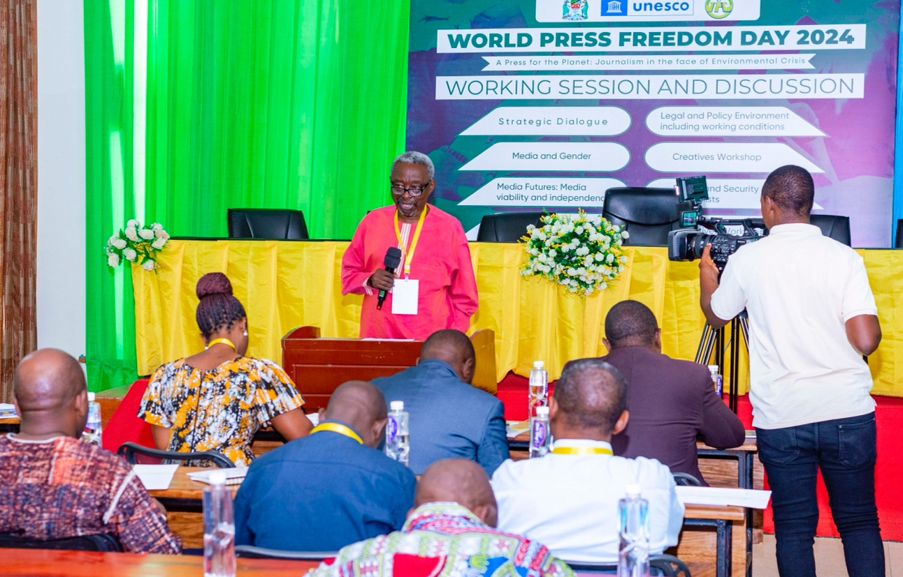
Jenerali Ulimwengu reflecting on Tanzanian media landscape

One thing that was laid down in journalism during the entire post-independence period was the boundaries of writing. It was a guided press freedom that directed what to do. In such a context, the don'ts far outweighed the dos. The philosophy of guided democracy also bred guided journalism, which dictated what to do and not to do. It was forbidden to challenge the broad political guidelines of the nation. The type of journalism and, therefore, the press freedom that was permitted spoke about implementing the policies of the ruling party. Any attempt to depart from reporting the broad guided party policies was a warrant for trouble. The inspiration for doing journalism was embodied in the ruling party of that time, either TANU or ASP and eventually CCM. Nevertheless, the attitude of dealing with individual personalities was broad as long as it didn’t challenge the reign of the broad ideology of the day. For instance, Jenerali Ulimwengu recalled an article he published in The Daily News under his column “The Way I See It,” which challenged an utterance of one Regional Commissioner from Arusha, who had threatened to condemn some indigenous community to Ujamaa Villages if they don’t change their behavior. He categorically differed with the said Regional Commissioner that his threat against the indigenous community was not in line with Ujamaa Policy. He reiterated that although such an article was received with smiling faces within governance quarters, he couldn’t dare to challenge Ujamaa Philosophy. For instance, he said even when things were not going well with the Ujamaa Village Program, it was suicidal to challenge it. The broad policy of Socialism and Self-Reliance (Ujamaa na Kujitegemea) was sacred, and those who dared to challenge it ended up either in detention or seeking political asylum abroad. Nevertheless, it would have been very difficult to publish any article that talked badly about Ujamaa and the Self-reliance policy. So, that was the actual scope of press freedom that was prescribed at that time—guided press freedom.

He further elaborated that the media outlets established from the 1960s up to 1992 were either owned by the government or the ruling party. The kind of press freedom that existed was constricted to one center of source of information. With the adoption of multiparty democracy in 1992, it opened the door for establishing media outlets. The period between 1992 and 1995 witnessed a significant increase in media outlets, including newspapers, radio, and television. This period can essentially be described as laying the foundation for the strengthening of press freedom in Tanzania, despite the journalism of that time having its professional shortcomings. It is in this context, the press freedom strides Tanzania made in that period under the leadership of the Second President of the United Republic of Tanzania, Ali Hassan Mwinyi, he can be called the Father of Press Freedom.

However, there were frequent conflicts between genuine journalists and the state. Some media outlets focused on writing the truth found themselves clashing with administrative authorities, including the closure of some media outlets. There was also a general problem of running media outlets on the required principles.

In the context of the current state of media and reality, the picture that emerges is that journalism has died. There are many reasons that can be cited as the cause for the decline of journalism in the country. The biggest reason is the government’s reluctance to allow strong, true journalism to thrive. What is happening now is guerrilla journalism. These are journalists who use the benefits of social media, who cannot be tracked, have no byline, cannot be followed, and make surprise attacks—guerrilla journalism.

Guerrilla journalism has created many problems. Issues of disinformation, misinformation, and false news now dominate. Social media as opposed to the mainstream media where an individual publishing news/information can be traced for accountability, is untraceable. Many vices are at play, affecting the public sphere spectrum. Just as vibrant media in the mid-90s played a significant role in the flourishing of democracy, like the growth of political parties, the continuous decline of media vibrancy is equally suffocating democracy and essentially the survival of political parties. Jenerali recalled the unilateral declaration of disbandment of opposition political parties in 2015 by the head of state and the fatwa to media outlets not under the government or ruling party’s armpit, as a self-evident of such interdependent relationship between press freedom and democracy.

In his remarks, Jenerali urged journalists to revive the media in Tanzania so it can assert its noble role—a public watchdog. However, he cautioned that reviving media alone may become a tall order if the political space is not free and open as media and politics are intertwined. He noted that when journalists are lined up for political appointments, then journalism turns out to be a task of dealing with press releases. Major vices in society, like corruption scandals and misappropriations of public funds, go untouched by the media.

Jenerali wondered how Tanzanian journalists could fail to connect the buoyancy lifestyle of civil servants with the level of poverty among citizens. A lot of money that should be directed toward fighting poverty ends up in the pockets of the elite, who shamelessly live luxurious lives at the taxpayers’ expense.

Equally, he was perplexed by the way the natural gas economy is being handled in the country, and all media are indifferent to that. He asserted that it is appalling to see how slow the government is in transforming the country from reliance on petroleum-powered vehicles to natural gas. Again, he challenged the media to note that there might be an unholy alliance between government officials and oil companies in sabotaging the national decision to migrate from petrol-driven vehicles to natural gas. That is why, as of 2024, only two natural gas filling stations have been built, both in Dar es Salaam.

Furthermore, he touched on the strictness of law regarding research under the Statistic Law, which demands government sanction before anyone publishes any research findings. He argued that while the Nyalali Commission of 1992, assigned to gather citizens' opinions on the viable political system for Tanzania, identified 40 oppressive laws needing amendment for the country to enjoy a multiparty system, not only some of those laws are still operational 32 years later, but more such laws have also been added on. He summed up by asking media stakeholders to do whatever it takes to revive media in Tanzania, paving the way for alternative thinking in our midst.

2.2.3 Panelists Articulation

A veteran Journalist Salim Said Salim refused to admit that Tanzania in the past did not have freedom of the press, especially during the one-party era. He insisted during the single-party system journalists were freer than today. He recalled some of the issues carried in newspapers, like the Daily News column “Action Line” and letters to the editor, which made individuals especially public officials, accountable for the issues raised. He further mentioned some public officials who resigned because of media reports during the single-party system. Nevertheless, he acknowledged that currently, doing investigative journalism is an uphill task due to the enactment of laws that somehow curtail research. He further asserted that there is a ‘nationalization of research’ in the country, citing the Statistic Act of 2015. He also called upon the media fraternity to keep pushing for the amendment of restrictive sections in the Media Services Act (MSA 2016) to promote and enhance press freedom in the country.

A senior journalist, Musa Juma, painted an alarming picture of the environment journalists operate in Tanzania. He asserted that about 80% of journalists in Tanzania work without formal contracts with their media outlets. The payment mode is a piecemeal, where the modus operandi is payment per story/article per square centimeter. He said it is as if labour laws do not apply to the media cadre in Tanzania. For instance, journalists have no right to leave, no medical insurance, no sick leave, and no off duty.

He concluded that the government has failed to enforce labour laws against media owners, on the pretext that if fully enforced, no media outlets will survive. It is against this background, he called upon journalists to be aware of their rights and join trade unions to assist them in collective bargaining and representation in industrial disputes. Like many other participants, he commended the media to focus more on investigative journalism stories that could attract public followers, as opposed to the press release syndrome, which has little effect on the public interests.

A renowned media law advocate James Marenga was saddened by the minimal amendment of the MSA 2016 that was done by the government in 2023. He recalled that stakeholders proposed 21 sections to be either revoked or amended from the MSA, but the government amended only nine sections, some partially. He urged the media fraternity to keep pushing for the amendment of the remaining sections. He cited the presence of the offense of sedition as appalling since the best practice globally attests that nations have done away with seditious provisions in their statutes.

2.2.4 Discussion from the Floor
A media lecturer, Dr Egbert Mkoko argued that journalism in Tanzania is in crisis due to several reasons. Among them, unfriendly political, constitutional, and legal environments for media; the weak economy of media outlets due to many continuing to live in a model dependent on advertising, which is no longer sustainable; the existence of an education system enshrouded in politics instead of focusing on quality, as evidenced by the competition to increase student enrollment without ensuring quality; education being turned into a business instead of a service; technological challenges and a society that has declined morally to the extent of also producing poor journalists.

To get out of this impasse, he suggested the need for political will to save the media sector from its current state, establishing a robust education system focused on quality, avoiding turning education into a business. He also urged media outlets to recognise that we are in an era of significant technological advancements, particularly digital advancements. He emphasised that innovation in media is crucial to benefit from these changes and remain relevant. Like other participants have suggested, he recommended amending policies and laws that hinder press freedom in the country.

Suleiman Msuya a secretary general of the Journalists’ Trade Union, apart from urging the government to enforce labour laws as it does in other sectors, he also wanted the economic condition of the media outlets to be examined carefully. He expressed his concern that the government's indifference to the economic state of media outlets could be interpreted as a motive to suffocate strong media to avoid potential harm to itself. He called for all media sector stakeholders to unite and raise their voices about the rights of journalists in the country.

Novatus – (Geita), a journalist shared his experience regarding employment contracts offered by media owners. He said he was given a three-month contract from one of the government media outlets, which did not have significant benefits as many would expect. However, later the contract was extended to one year, without the right to health insurance. He urged journalists, regardless of their professional associations, to unite to collectively face the challenges posed by media owners in the country.

2.2.5 Resolutions
The session came up with resolutions which was apportioned to media practitioners on one hand and the government on the other.

2.2.6 Resolutions for the Government

1. To uphold the principles of democracy, the government should review the statistics law related to conducting research as it hinders journalists from conducting research freely to assist the public and the nation as a whole.
2. The government should pressure media owners to comply with labour laws by paying employees their salaries and other rights such as work contracts, insurance, and remit their dues to the social security entities like National Social Security Fund (NSSF) and Public Sector Social Security Fund (PSSSF).
3. There is a great need to review the Media Services Act to meet the benefits of noble journalism for the benefit of the public.

2.2.6 Resolutions for Journalists:
1. Media practitioners should strive to revive serious and responsible journalism like rekindling investigative journalism, for the needs of the public/community.
2. There should be concerted efforts to push political leadership with courage to have the political will and see the importance of creating a freer working environment by amending laws that affect the media industry.
3. Journalists and media institutions should unite and have one voice to fight for journalists' rights.
4. There is a need to consider the contribution of the media to the country's economy to inspire the government to recognise the importance of the media for social development and justice.
5. Build capacity for journalists, editors, and media managers to recognise their role in bringing about change and restoring the lost dignity of the media industry in the country.

2.3: Strategic Dialogue: Journalism for development (the role of journalism in promoting democracy, political accountability and sustainable development)

  - Introduction
The Strategic Dialogue - Journalism for Development, was a side event led by UNESCO and Tanzania Editors Forum (TEF), with the aim to explore the pivotal role of journalism in fostering democracy, ensuring political accountability, and driving sustainable development on a global scale, and provide actionable insights on how to meaningful invest in public interest journalism.

2.3.1 Opening and Welcoming Remarks
The session was moderated by Mr. Machumu Tanzania Editors’ Forum (TEF), Vice Chairman and Managing Director of Mwananchi Communication Ltd who thanked participants for choosing their side event. He proceeded to introduce the panelists both to the participants and the topic. Explaining the topic, he pointed out the worldwide disregard towards the fate of quality journalism in spite of its undeniable contribution in fostering democracy, political accountability and sustainable development. Emphasising on this, Machumu highlighted the effectiveness of quality journalism against misinformation and disinformation suggesting without it the world will be in shambles. The panelist of the session featured in Mr. Zlatan Milisic, UN Resident Coordinator in Tanzania; Prof. Jennifer Thomas, Howard University; Ms. Kemi Williams, Development Director British High Commission in Tanzania; Mr. Theophil Makunga, Media Consultant and Former TEF Chairperson; and Mobhare Matinyi, Director of Information Services and Chief Government spokes Person. The session was attended by 50 participants.
2.3.2 Panelist Pondering Parameters
Setting the conversation tone, the moderator specified the session’s objectives: To probe the current thinking and find answers to four questions: - What is the role of journalism in promoting democracy? How can it ensure accountability? How journalism drive sustainable development? Lastly, providing actionable insights on how to effectively invest in public-interest journalism. This was followed by a set of other questions prompting dialogue on related issues.

2.3.3 Misinformation, Disinformation, and Fake News
Discussing this as a subject affecting quality journalism panelists shared the following insights.
- The negative impact of technology development towards journalists and media, has turned many without proper education into information providers using their gadgets and modern communication channels to engage in topics they are unknowledgeable of.
- Immaturity of African countries’ democracy enables political propaganda to thrive for personal agendas and gains.
- The impact of the cold war has led to competition in setting the global world order, power and populism which eventually contribute to complex narratives.
- The need for real journalists to adhere to their professional ethics and guide consumers amidst the ongoing convergence confusion and intentional disinformation.
- Acceptance, adoptability and proper utilisation of technological advancement as a tool for media to protect professional journalism in today’s world of communication and information.
- The role of media and journalists to strengthen their professionalism, independence and ingenuity in passing objective stories to oppose deliberate confusion supported by powerful people, companies etc.

2.3.4 Government Actions Towards Combating Misinformation
Addressing this Government Chief Spokes Person Mr. Mobhare Matinyi, first applauded traditional media particularly newspapers for making efforts to have their products on digital platforms and referred to the act as bringing balance in the confused media market. On government mitigation actions, he talked of the legal framework including laws and policies that are in place to guide online interaction under the supervision of TCRA which is a government electronic communications regulatory body. In addition, he explained the government as the key information holder and provider is putting emphasis on its entities being transparent and open either through journalists or other mass communication platforms, so as to ensure the public has the right information.

2.3.5 Government Legislation Impact on the Sector
Mr. Matinyi discussed the Media Services Act of 2016, highlighting its ease of newspaper registration, promoting the journalism profession, and resulting in increased registered newspapers. He noted that the law governing electronic media has simplified TV, radio, and online TV registration. He emphasised the stakeholder discussions, reducing contradictions, and the government's balanced enforcement of the law.
2.3.6 Balance Between Government Strategic Communication and Media Transparency
Mr. Matinyi assured a national communication strategy is forthcoming, observing accountability and transparency rules, enabling journalists and the public to access accurate government information. The strategy will also differentiate between government officials and liability bearers.
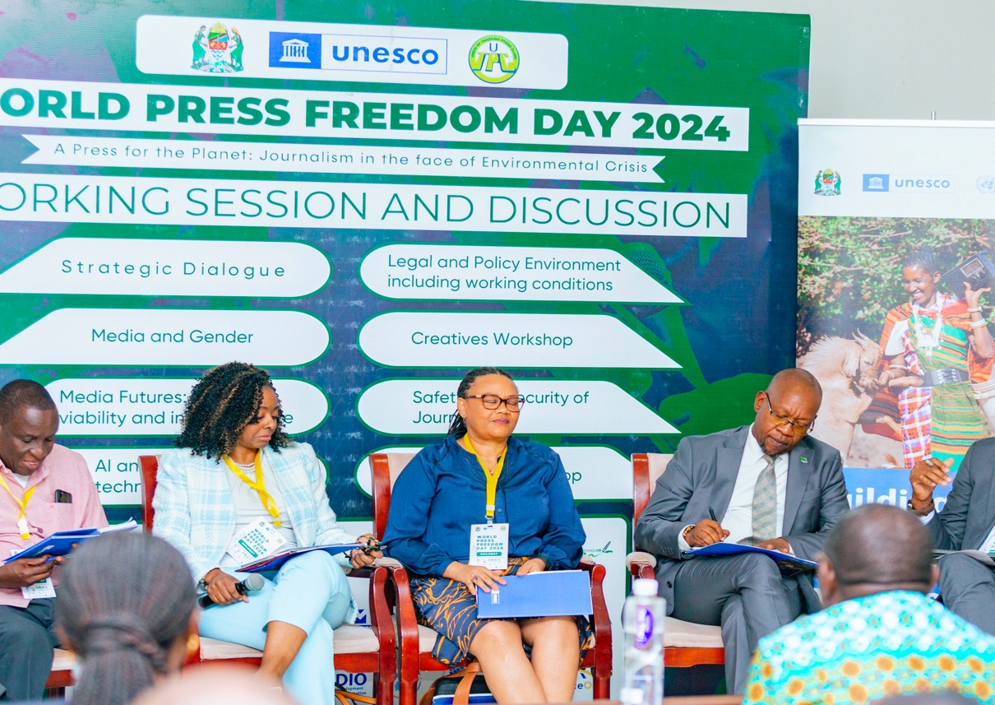
From Right: Theophil Makunga, Media Consultant and Former TEF Chairperson; Prof. Jennifer Thomas, Howard University; Ms. Kemi Williams, Development Director British High Commission in Tanzania; and Mr Mobhare Matinyi, Director of Information Services and Chief Government Spokes Person.

2.3.7 Tanzania Media and Sustainable Development Goals (SDGs)
Mr. Zlatan Milisic acknowledged journalists' critical role in promoting SDGs, noting significant delays in achieving targets. He discussed outreach efforts to align national development programs with international development partners' focus. He commended journalists for translating SDG goals into local perspectives, identifying gaps, and communicating solutions. He urged continued focus on critical SDGs like no poverty, employment, food systems, and agriculture.
2.3.8 Tanzania's Progress on Climate Action (SDG 13)
Mr. Milisic noted Tanzania's relatively better performance in climate action, but emphasised the need for further efforts due to recent climate disasters – he took cognisant of incidents like mud-flood in Hanang, Manyara and unprecedented downpour which has caused heavy floods in various parts of the country. He encouraged journalists to simplify SDG data for public comprehension, aiding in avoidance of similar situations and improving progress. He highlighted the role of journalists in monitoring SDG accountability and promoting global burden-sharing for climate action. He noted the ongoing global dialogue over financing for SDGs particularly climate action and countries that have heavily contributed to the climate stress being asked to pay the price. He said there is an international plan on burden sharing across states.

2.3.9 Role of Journalism in Democratic Governance and Accountability
Ms. Kemi Williams emphasised journalism's role in providing independent, factual information, essential for democratic societies. Journalists shape democracy narratives, support informed citizen decision-making, and enhance political participation, reduce corruption, and improve service delivery. She stressed the increased importance of professional journalism amid misinformation.

2.3.10 Media Freedom Coordination and Investment Support
Ms. Williams addressed global media freedom deterioration, advocating for protection against censorship, harassment, and attacks on journalists, especially women. She emphasised linking media freedom to civil society, accountability, and transparency in democratic societies. She advised the Tanzanian government to uphold media standards and learn from regions with protected media freedom.

2.3.11 Supporting Public Interest Journalism
Mr. Theophil Makunga urged journalists to leverage technological advancements and social media to disseminate accurate information. He emphasised the need for innovative content understanding through regular research and creativity in news writing.

2.3.12 Editors as Catalysts of Development
Mr. Makunga suggested editors understand societal content needs through regular research. He emphasised creativity in news writing, adding value to mainstream media by skillfully addressing the "H" in 5W and H principles for in-depth coverage.

2.3.13 Journalism Education and Ethical Standards
Prof. Jennifer Thomas highlighted the importance of understanding journalism's purpose, ethical implications, and the power of storytelling. She emphasised foundational journalism principles—fairness, accuracy, truthfulness, and clarity—and urged journalism educators to equip students with these basics.)

2.3.14 Effectiveness of the Firewall Approach in the US
The metaphorical firewall approach was explained as operational boundaries removing business-side interference from news coverage. Strengthening these boundaries and engaging media owners and power holders were emphasised.

2.3.15 Reaction From the Floor and General Discussion
Highlighted down are contributions and questions posed from the floor.
How can traditional media in Tanzania leverage technology in the midst of economic crisis it facing now
    - Technology has enabled everyone to become a journalist and with it, there are a lot of fake and unbalanced stories that lack objectivity, accuracy etc. therefore it’s the duty of professional practitioners to uphold ethics from training institutions to newsrooms by using data, research and creativity.
    - Technology has impacted press freedom with convergent confusion among others, with the invention of AI the stakes are even high, what can media do to tackle the problem?
    - Technology has taken the mainstream media by surprise and there is a need to embrace the changes and become proactive, creative and innovative so as to reduce the negative side of it.

2.3.16 Final takeaways from the panelists
As their closing remarks moderator asked panelists to give their actionable insights on how to meaningfully invest on public interest journalism. This chance was also used to address matters raised from the floor during general discussion.

- Mobhare Matinyi, Director of Information Services and Chief Government Spokesperson
- To add another W, on every element of the 5Ws & H to unravel true stories behind stories, stories that are normally interesting to the public.

- Ms. Kemi Williams Development Director British High Commission in Tanzania
- Adopting technology and inclusive business models.

- Prof. Jennifer Thomas, Howard University
- Media professionals and officials should guide the public to be smart consumers against misinformation and AI.
- Knowledge of the public and community issues, returning to basic story coverage principles (KISS).
- Journalists should embody FAITH: Fair, Accurate, Interesting, Thorough, and Human.)

- Mr. Theophil Makunga, Media Consultant and Former TEF Chairperson
- Developing business models considering technological changes.
- Emphasizing day 2 journalism and perseverance.

- Mr. Zlatan Milisic, UN Resident Coordinator in Tanzania
- Engaging journalists in addressing the 17 SDGs for collective solutions.

    - Closing Remarks.
Moderator of the session Bakari S. Machumu thanked the organisers as well as the participants for a fruitful session and adjourned the meeting.

2. 4: MEDIA AND GENDER SESSION

2.4.0 Introduction
Promotion and protection of women's and girls' rights is critical in the attainment of inclusive and sustainable development in Tanzania. Equality and empowerment of women is one of the 17 Sustainable Development Goals (SDG 5). Attainment of gender equality by 2030 requires urgent action to eliminate the root causes of all forms of gender violence, discrimination, and exploitation that still curtail women’s and girls’ rights in public and private spheres.
Media and Gender were one of the seven Working Sessions and Discussions in this year’s World Press Freedom Day national conference. This Session was chaired by TAMWA, BBC Media Action, and DW Akademie. The panelists of this session were: Dr. Rose Reuben (TAMWA), Dr. Dotto Paul Kuhenga (UDSM), Faraja Samo (BBC Media Action), and Zania Miraji (Dodoma FM). The Moderator was Mariagoreth Richard. The topic of discussion reflected on whether the Tanzanian media have done enough to report the impact of climate change to different social groups, women and girls in particular.
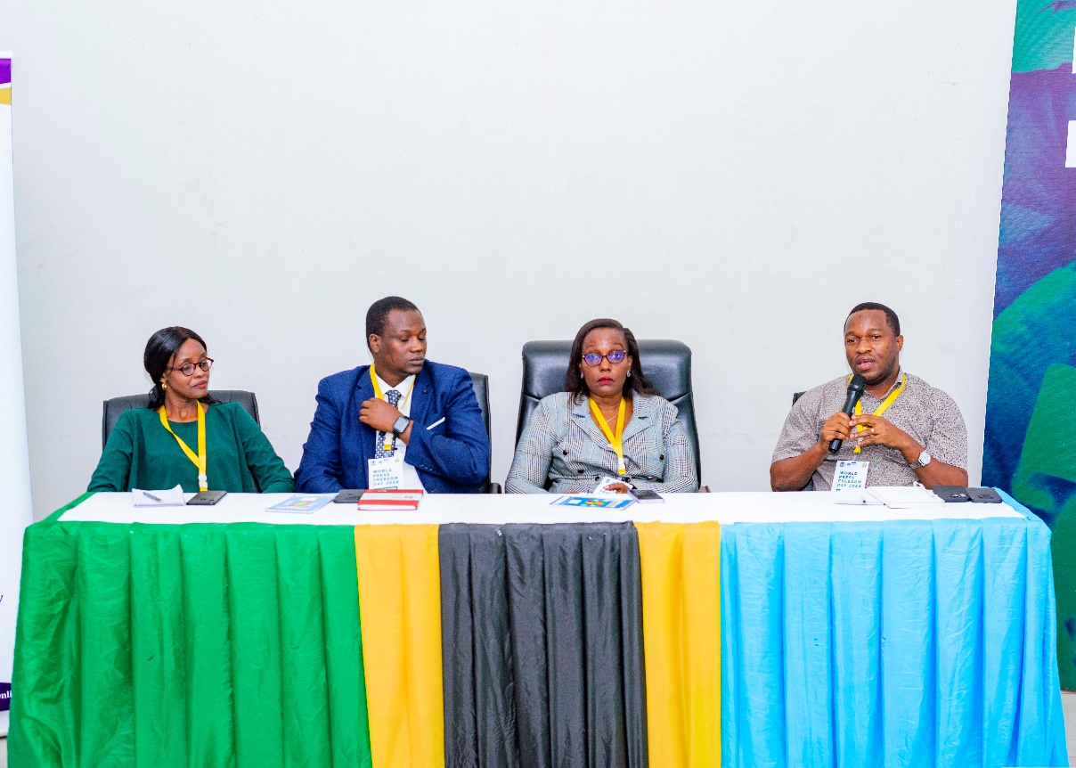
Panelists of Media, Gender and Climate change from left is Zania Miraji, Faraja Samo, Dr Rose Reuben and Dr Dotto P. Kuhenga

2.4.1 Insights from the Panelists
The session opened with the panelists giving a preliminary understanding of environmental challenges and climate change from a gender lens. Generally, the impact of climate change from a gender perspective encompasses the examination of how climate change affects the socio-economic well-being of men and women. Climate change impacts the environment and natural resources therein which human beings depend on for their livelihoods. Climate change has become a major source of natural hazards such as recent floods in Rufiji, and landslides in Hanang, Lindi, and Mbeya. Unfortunately, women and children are the main victims facing high risks and bear heavy burdens from the aftermath of climate change’s impacts. Panelists and contributors unanimously agreed that the media in Tanzania has not done enough to comprehensively inform and educate the general public on climate change issues. Dr Rose Reuben [TAMWA] observed that:
“We don’t get well-detailed content on climate change attributed by journalists lacking knowledge of climate change or creativity to merge climate change issues with other socio-economic issues such as health, economics, and politics they frequently report. This is because climate change impacts our communities in different ways and areas…[Also] the media has not done enough to portray accurately initiatives and efforts that have been taken by the government, state, and non-state actors to deal with climate change in Tanzania – Dr. Reuben [TAMWA]

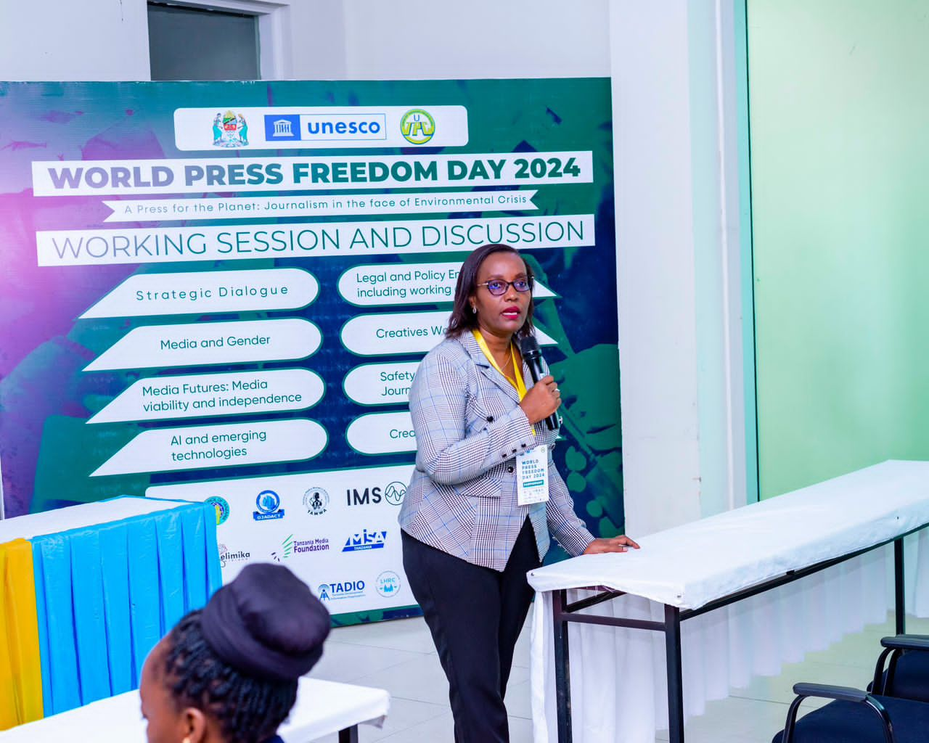
The Panelist, Dr Rose Reuben, TAMWA Executive Director making a point during the Media, Gender & Climate change dialogue.
Dr Paul Kuhenga highlighted key criteria for evaluating whether the media has met its obligations of reporting climate change. Among the criteria are the depth of coverage of climate change stories, the quality, and depth of coverage of such issues, and whether climate change issues were accurately analysed and put into proper context for the target community to understand. Furthermore, it was observed with great concern the lack of specialisation in the media industry is the one of the reasons for the minimal coverage of climate change issues. Most journalists in newsrooms assigned to report climate are general reporters, who are not familiar with the phenomenon. Media houses are under-capacitated to produce journalists specialised in environment and climate change and other fields. Additionally, the scanty manpower in newsrooms which overstretched to report other issues within deadlines denies them time to cover climate change issues. “This situation leads to climate change issues to be partially and scarcely reported in the media hence denying the public access to comprehensive and accurate information and education for them to make informed decisions to prepare themselves to live with it, or benefit from opportunities brought by climate change” – Dr. Reuben [TAMWA].
Similarly, the media coverage of climate change issues has inadequately reported within the gender perspective despite the majority of victims being women and children. It was noted that women and youths are the main groups with limited access to climate change information and education. Access to such information and education would have increased their participation in climate change mitigation initiatives and transformed them as change agents of climate change in Tanzanian society.
Media play a critical role in disseminating the right and accurate climate change information and education to raise citizens' awareness and understanding for them to participate in mitigation initiatives and take informed measures. The media has a professional obligation not only to report climate change issues comprehensively and accurately but also to shape climate change narratives that motivate community participation in environmental protection initiatives. However, panelists observed that media reportage of climate change issues is often challenged by the business interests of media owners which are essentially making profits. Therefore, as long as climate change stories do not generate revenues, their coverage has remained scanty and partial in the media.
Other challenges that impede journalists and media in Tanzania from reporting climate change issues intensively and extensively include:
- Most journalists lack a good command of climate change issues and the requisite journalistic tools to competently and comprehensively report climate change issues. Most of them are general rather than pecialised journalists, hence, end up reporting partially those issues.
- The inadequate number of journalists in the media houses/outlets is forcing them to work on multiple journalistic assignments within deadlines. This situation denies journalists ample time to adequately prepare and report comprehensively on climate change issues.
- Climate change reports are communicated scientifically and in the English language hence demotivating and restricting most journalists from accurately analysing, contextualising, and reporting climate change stories.
Despite media shortcomings, there are media outlets such as Dodoma FM which have been active in reporting climate change issues to local communities across the country. According to the manager of Dodoma FM, Ms. Zania Miraji, the community radio stations adopted a participatory approach in sustainably producing and airing climate change programs that included diversified voices of women, and other disadvantaged social groups such as people with disabilities, and people residing in peripheral areas. The collaborations and community support initiatives have produced positive results in broadcasting climate change issues that contributed partly, to transforming Dodoma from a semi-arid region into a greenish area.
However, Ms. Miraji cautioned on the relentless dependence on donor-funded media and climate projects for the comprehensive reportage of the issues since they always lack sustainability. “Instead of depending on donor support for reporting climate change which is unsustainable and short term, our media should prepare and implement a strategic plan that will ensure media is capacitated to extensively and sustainably inform and educate our people on these issues” – Ms. Miraji [Dodoma FM].

2.4.2 Media and Gender Discussion
Contributors discussed the obstacles of the media to reporting climate change issues in Tanzania. Among the obstacles are newsrooms lacking journalists and editors with competency in reporting climate change. This is, partly, attributed to a lack of interest, passion, and self-driven desire to search and know about climate change issues among journalists and editors. These deficiencies contributed to partial reportage of climate change issues in the media. Ms. Joyce Shebe from TAMWA pleaded with journalists to take self-initiatives to know more about climate change issues to competently produce and report content that influences the attitude and behavior of community members toward climate change. “Media and journalists should make climate change an agenda in their routine reportage. We need to multiply climate change stories, ensure their accuracies, and ensure comprehensive coverage of issues to raise awareness and understanding of our fellow citizens” – Ms. Shebe emphasized.
On the gender front, the media has to do more to report climate change issues through a gender lens. Gender considerations in reporting climate change issues are critical because the impacts of climate change affect mostly women and children as well as people with disabilities. Gender-sensitive reporting of climate change aims to inform and educate the community on how to deal with the phenomenon including implementing mitigation measures against its effects which affect this large group. Ms. Shebe shared a living example of floods that occurred in Rufiji in which women and children were the main victims. She urged the media to be:
“…gender-sensitively and responsibly report climate change extensively and comprehensively to keep the general public aware of the magnitude of the problem and how they can participate in mitigating its impact…gendering climate change reporting is essential because climate change is knitted to the problems of food insecurity, water scarcity, and unclean breathing air. These problems are linked to women because they are the ones who walk long distances to fetch water and are the main agricultural producers of food, hence, making them the main victims of this phenomenon. This relationship between women and climate change must be explicitly visible in the media coverage” – Ms. Shebe [TAMWA].

Furthermore, the media continues to be challenged by the lack of research data on the impact of climate change on women and children. As a result, the media and their journalists provide shallow coverage with unconvincing supporting data on the effects of climate change on women and children. Contributor, Ms. Hilda Stuart questioned the role of the media in generating its data on the victims of natural disasters caused by climate change. “Our country experienced major climate change-caused floods, landslides, and Elnino rains which caused loss of lives and human suffering mostly to women and children in Hanang, Rufiji, Mbeya, and Lindi. Unfortunately, the media has no credible researched information on how many women and children were affected by those disasters. Such data are always missing in their reportage.” – Ms. Stuart. Also, the media has failed to report comprehensively the impacts of climate change on food security which has a direct connection to women.
There was a consensus among the participants on the need for journalists and media houses to creatively and innovatively repackage and report climate change issues by merging them with other socio-economic and gender issues. “When you innovatively repackage and report your climate change content or stories they can influence investors and development partners. We need to report these issues extensively and creatively to attract investments” – Stuart. Additionally, the media should also focus on reporting on the environmental impacts caused by the extractive industries' activities. It is important also for the media to report safety and security issues with climate change and gender.

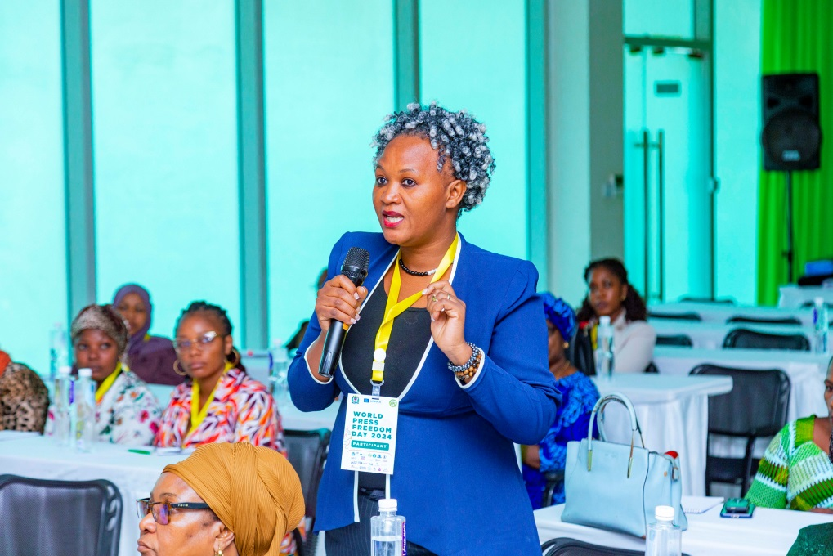
Ms. Hilda Stuart making a point during the Media and Gender Session

Although the media of Tanzania has not done enough to report climate change due to myriad factors, they have tried their level best to cover selected issues. However, it is not for the media alone to make efforts to ensure more climate change issues get media attention. It is high time for all sectors to be responsible and accountable in dealing with this phenomenon because climate change is a cross-cutting issue. Media has been left alone with little support to effectively participate in public awareness creation and mass education on climate change. Contributor, Filbert Mwarabu further observed that media in Tanzania are forgotten, or systematically excluded in regional and international climate change meetings and conferences. “Participation of Tanzania media in global and regional climate change conferences that discuss strategies and lay down plans to mitigate the impacts of climate change is minimally low or nonexistent. Consequently, the global and regional agenda on climate change discussed and agreed in these conferences rarely get enough coverage in the local media in the country” - Mwarabu. To win this fight, the media and journalists need to participate fully in the planning and implementation of strategies and climate change programs and interventions. This initiative can contribute to increasing media reportage of climate change issues.
Among the strategies to increase coverage of climate change issues in the Tanzanian media is for journalists themselves to possess two important qualities. Ms. Penzi Nyangumi mentioned that the first quality requires journalists to have or develop a firm interest in reporting climate change issues. Secondly, journalists need to set aside time to prepare and report comprehensively on climate change issues. Ms. Anjela Mangénya cautioned against reading laziness amongst journalists. She observed that journalists dislike reading thus wasting the opportunity of enlightening themselves on many issues including climate change.
“The problem is, we are lazy when it comes to reading, we hate reading. These issues that we are discussing now are not new, they have happened before, researched, and documented. It is unfortunate we, journalists, are not accustomed to visiting libraries to read and equip ourselves with credible and in-depth background information for the stories we write.” – Ms. Mangénya.
Relatedly, journalists have not adequately taken advantage of the internet and digital platforms to explore and access a wide array of researched information. It was informed that the internet contains hundreds of research sites and databases on climate change conducted in Tanzania and other countries globally. These researches are useful in enriching climate change stories for media reporting. However, it was observed that journalists and media in periphery regions and districts in Tanzania encounter budget challenges to reach areas affected by climate change and cover stories. Sheila Khatibu, a contributor from Lindi, shared her experience on how journalists struggled financially to comprehensively report the victims, mostly women and children, of the landslide natural disaster that occurred in Lindi region. “Journalists working for media outlets in peripheral regions/districts are under-capacitated to effectively report the impact of climate change-caused disaster and victims who were mostly women and children.” – Ms. Khatibu.
2.4.3 Role of Media Leaders in Promoting Climate Change Reporting
- Engage in participatory stakeholders’ dialogues aimed at strategising on how to mobilise resources that contribute to capacity building of their journalists on reporting climate change issues.
- Build and strengthen the capacity of their journalists by supporting their training in climate change and undertaking climate change stories assignments.
- Promote research-based climate change reporting in newsrooms. Journalists should make use of credible research information sources including the Centre for Climate Change Studies of University of Dar es Salaam. This Centre has conducted and documented vast research in climate change, hence, the credible source of climate change research. “However, journalists and media have not done enough to access and report these researches due to lack of interactions between the media and research institutions.” – Dr Kuhenga informed.
- Journalists should make self-initiatives to read extensively to broaden their knowledge to efficiently report climate change issues accurately and comprehensively.
- Media should adopt the gender-inclusive approach in the production and coverage of climate change issues to ensure equal representation and participation of females and males in initiatives to tackle the impact of climate change in Tanzania.
Participants called on the media houses to make climate change an agenda in their routine coverage. Making climate change a media agenda will allow the media houses to prioritise reportage of these issues for a considerable time for fruitful engagement and participation of community members in mitigating its impacts. Also, the media should invest in the reportage of climate change. Investment should be directed at capacity building of journalists in climate change through financing media production of stories/content and comprehensively reporting them with no strings attached. Climate change is a cross-cutting issue involving different sectors. Therefore, state and non-state actors and stakeholders including the government, organisations, and individuals should work with the media industry to ensure the public develops a relevant understanding of how to deal with climate change. Universities in the country should introduce short courses on media business to equip media practitioners on how to make media financially independent from vested interests.

2.4.4 Online Violence Against Women
Shamim Nakiryowa from DW Akademie delivered a presentation on online violence against women. Her account is based on the survey which examined media coverage of online violence against women in East Africa conducted by DW Akademie in Tanzania, Uganda, Rwanda, and Kenya. The presenter noted that online violence against women manifests in various forms including body shaming, insults, non-consensual sharing of nude photos and video clips, and cyberstalking. These violent acts are ingrained in gender inequalities and discrimination. According to survey results, media reportage of online violence against women across the surveyed East African countries was harmful to the victims rather than solving the problem.
The report found that media outlets employ attention-grabbing headlines and sexualised photos that focus on victims’ nudity or acts rather than that of the culprits. Regrettably, the findings implicate the media outlets for ignoring the seriousness of this problem as they sensationalise and trivialise such incidents. Furthermore, their reportage does not meet journalistic ethical standards of respecting human dignity and promotion of decency. Consequently, this kind of reporting has led to victim-blaming and shaming causing the victims to undergo traumatic experiences.
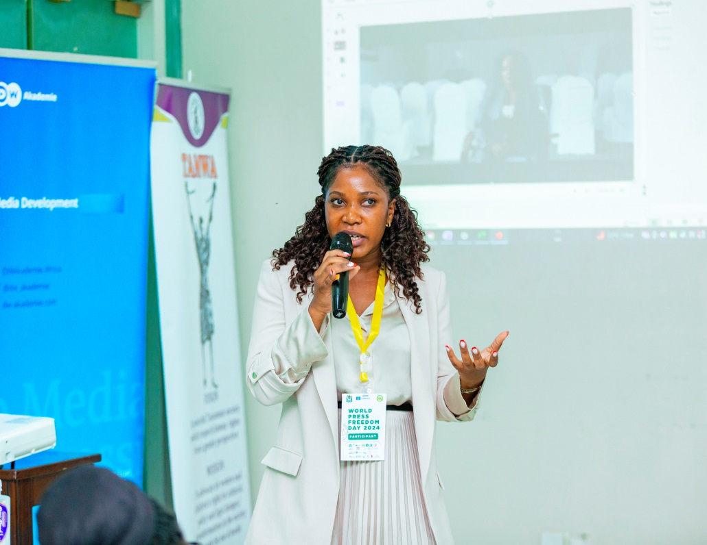

Ms. Shamim Nakiryowa from DW Akademie making a presentation on online violence against women
It was noted with concern that media glamourising online violence against women issues could spill over from private online spaces to public spaces. Therefore, it is critically important for the media outlets to adhere to a professional code of conduct ensuring responsible and sensitive reporting of subjects with a gender eye and without perpetuating violence against women and girls. In addition, there is a dire need to invest more in journalistic training and advocacy with a focus on ethical and gender-sensitive reporting of online violence against women and girls. Similarly, media advocacy strategies should focus on influencing editors and managers to take a gatekeeping stand against content glorifying online violence against women and girls and promote the generation of creative content to counter this dehumanising reporting. Media regulators such as TCRA should be more vigilant and aggressive to hold online media and digital platforms accountable for posting dehumanizing content against women.

2.5: SAFETY AND SECURITY, PRESS FREEDOM, AND ELECTORAL LAWS SESSIONS AND DISCUSSIONS

2.5.0 Introduction
This session was chaired by UTPC and covered three presentations and discussions on issues of safety and security issues and the media, the state of media freedom and access to information, election laws, and the role of media/journalists in covering the electoral process. The presentations were made by Victor Maleko (UTPC), Edwin Soko (OJADACT) and James Marenga (MISA Tan). The presentations and general discussions were moderated by Mary Kafyome (UDOM).
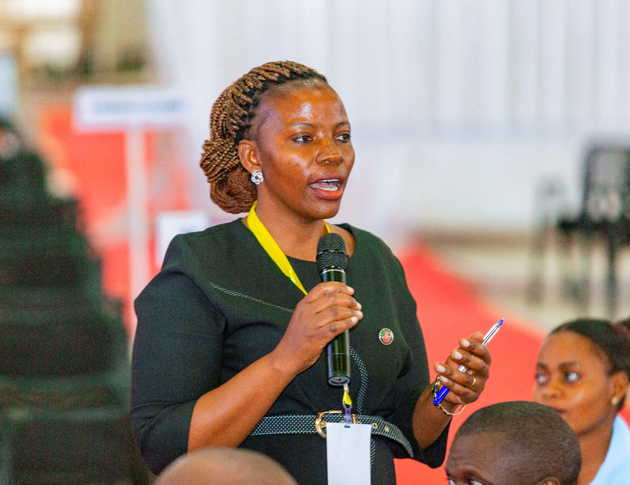

Mary Kafyome, moderated the session on safety and security, media freedom, and election laws
2.5.1 Safety and Security
The presentation focused on three main issues: Safety and security dialogues and safety mechanisms for journalists; current trends in journalist safety and security; and violations committed against media and journalists. Also, the presentation highlighted key challenges and opportunities for improving the safety and security of journalists, developing and implementing tailored strategies for safe reporting during elections such as training, resource mobilisation and allocation as well as coordination with relevant stakeholders.
It was reported that the UTPC media violation tracking records show a slight decline in some incidents. For instance, the data available indicated a 21.7% decrease in violation incidents in 2023 which recorded 18 incidents compared with 23 recorded in 2022. The media violation cases recorded in 2023 were categorised into six different types, out of them four cases involved life-threatening, three incidents of denial of access to information, one case concerning assault, two were on physical attacks, seven involved police arrest and detention, and one incident was a case on defamation. The report data by regions showed that Iringa had three cases of violation, Mara recorded three cases, while Songwe, Shinyanga, Tanga, Kilimanjaro, Arusha, Mbeya, Kigoma, Ruvuma, Lindi, Morogoro, and Dar es Salaam each had one incident.
Efforts to improve the safety and security of journalists involved conducting a series of safety and security dialogues in six regions namely Dar es Salaam, Manyara, Mara, Katavi, Iringa and Songwe. The trainings were participatory and included strategic stakeholders such as the police force which resulted into decline of violation incidents by police who have been regarded as major perpetrators of these abuses.. Regarding mechanisms for protecting journalists from potential safety threats, the presenter informed that the National Safety and Security Committee (NSSC) and Rapid Response Committee (RRC) were formed.
Several challenges to the safety and security of journalists were mentioned including the continuation of violations committed against journalists; journalists’ failure to personally report violations committed against them; and, media houses’ lack of newsroom safety and security internal policy for the protection of their journalists. The lesson learnt from safety and security interventions is the fact that collaboration is vital in strengthening national and international solidarity.

2.5.2 State of Press Freedom and Freedom of Expression
This presentation was made by Edwin Soko from OJADAT. In his presentation, he assessed the state of the media industry in Africa and the prevailing challenges of media freedom. He also provided analysis and case studies as well as initiatives for the advancement of press freedom. The presentation informed that the media industry in Africa, East Africa in particular, continues to face legal, policy, and security challenges in discharging its professional duties. Copy-cut enactment of legislations and regulations that restrict the media and media practitioners from exercising professional independence in newsrooms have a negative impact on the democratic processes and good governance.
Recent efforts of media stakeholders in some countries such as Tanzania in advocating for legal and policy reforms, improved the state of safety and security of journalists. This has positively improved the work of media as practitioners exercised some level of freedom in discharging journalistic duties. Despite this promising progress, much needs to be done to advocate for meaningful reforms of media laws and policies with claw-back clauses and restrictive provisions that curtail the freedom and independence of the media in most African countries. The tendency of some African governments to cut and paste restrictive legal provisions has led to similar media laws.
According to Press Freedom Index 2023, twenty-three (23) African countries out of twenty-eight (28) were classified as Bad or Very Bad in promoting press freedom. The report published by Reporter Without Borders in 2023 identified media content censorship through newsroom gatekeeping and the use of internet shutdown mechanisms specifically during election times as one of the challenges of press freedom. Also, though the internet and digital technologies have broadened the scope of freedom of information and journalism practice in Africa, still, restrictive legal measures have been used to regulate and control internet freedom hence affecting online journalism practices.
The safety and security of journalists remains a challenge among East African countries. For example, Kenya, which is considered a beacon of press freedom, leads its East African neighbours by recording the highest number of violations against journalists and media. Data showed that press freedom violation cases have been on the rise from 70 in 2021 to 104 and 124 in 2022 and 2023 respectively. Relatedly, between January and February 2024, the country recorded 25 press freedom violation cases. Most of these violations were attacks committed by the police force and government authorities against journalists. On the contrary, Tanzania has recorded the lowest number of press freedom violations with only one violation incident involving the police force.
Countries have put in place mechanisms to ensure the protection of the safety of journalists. In 2018 Kenya instituted National Safety and Security mechanisms and became the first East African country to have the mechanism of protecting journalists. Uganda has several media organisations that work to defend and promote the safety and security of journalists. However, the country has recorded a high number of media freedom violations mostly on safety and security which were captured by Human Rights Management for Journalists of Uganda. Most violations were committed by the police force and the army. Out of 104 violations committed against journalists and media, 63 were assaults, 26 arrests, eight cases were the destruction of working equipment, and seven threats. These incidents occurred despite the establishment and operationalisation of the National Coordination Mechanism for the Safety and Security of Journalists. Ethiopia is among African countries with high infringement of human rights, and denial of access to the internet. According to the report published by Reporters Without Borders, 15 journalists were detained in 2023. Despite these violations, the country, with the support of UNESCO, established a Safety and Security Mechanism.
Overall, concerted efforts of different media stakeholders including the government, media practitioners, implementing partners, and academic community are needed to advance press freedoms. These stakeholders in addition to regional and international bodies as well as technology companies play an essential role in producing multidimensional stakeholder solutions to improve media freedoms and guarantee journalists' safety both in online and offline environments.

2.5.3 Election laws and Journalists’ role in covering electoral processes
This presentation was made by James Marenga of MISA Tanzania. The presentation highlighted the importance of professionalism of media during election periods. Media coverage is the very lifeblood of election politics as it shapes the perceptions on political ideologies, manifestos, promises, and political action.
It is imperative for journalists covering elections to demonstrate requisite knowledge of the Tanzanian electoral laws by heart. They ought to be conversant with the General Elections Act, Elections Expenses Act and Political Parties Act, Constitution of the United Republic of Tanzania of 1977 as revised from time to time, Zanzibar Constitution of 1984, and Zanzibar Election Act.
Election is a process, the media should be conversant with all steps of the electoral process from voters’ registration, candidates’ nomination, campaigning, voting, ballots counting and results announcement. The role of the media is to keep the public well informed about every step of the electoral process so that eventually voters can make an informed decision on voting day. In this whole process, the media and journalists are regulated by specific electoral laws and regulations. Experience has shown that journalists covering elections failed to discharge their duties due to limited legal awareness of the changing media roles at each step of the electoral process. “Once the polls have opened, the role of the media changes from what it was during the campaign period. Therefore, specific rules may be devised to govern this shift” - Marenga. Note that, in practice, the rules to govern the shift may have taken place earlier, with an embargo placed on political campaign reporting, opinion poll reporting, direct access broadcasts or advertisements.

2.5.4 General Discussion
The discussion dwelled on what need to be done to ensure safety and security of journalists during the upcoming local government elections.
- Journalists should stop exercising self-censorship in reporting election issues. They should uphold professional standards of reporting newsworthy issues impartially and objectively. They should discharge their professional duties with dignity, avoiding using divisive and offensive language which leads to confrontations with the police force hence putting them in a retaliatory situation.
- Journalists reporting elections should work in observance of and compliance to the instructions or guidelines in restricted areas that require them to do so to avoid trespassing or legal infringements.
- Journalists safety and security should be guaranteed and protected at all times during election coverage. Their safety is often threatened due to constant psychological and physical attack every time they disclose or in the process of disclosing the truth to the public.
- Journalists reporting elections should be upright, constantly avoiding associating or affiliating themselves with any other groups inclusive of political interest groups to ensure their safety and independence during reporting elections.
- The existing governing systems of the media industry, specifically the responsible Ministry of Information, does not have clear guidelines indicating where the safety and security of journalists starts and ends. Therefore, it is the responsibility of every journalist to change and start to strongly advocate for and defend their interests, take lead in solving their own problems, and join journalists’ professional associations for a common good.
- Media houses in collaboration with media stakeholders should pour resources to support journalists’ coverage of elections independently. One specific concern is transport for journalists to move from one election site to another to cover stories. Transport uncertainties jeopardise journalists’ safety and security as they are forced to depend on political parties, candidates, and other unknown sources. Section of journalists suffered abuse and harassment for failure to report favourably for the transport sponsor.
- Safety and security training to political leaders is essential to increase their participation and support in the protection of journalists’ safety during election times.
- There is a need to involve journalists in the craft of guidelines and rules of election coverage in the entire electoral process.
- Journalists need to adhere to ethical guidelines and code of conduct of journalism during the coverage of elections.

2.6: Media Futures
2.6.0 Introduction
The media sector in Tanzania is going through a period of many challenges. Among them are economic instability, the public increasingly losing trust in the media, failure to leverage on the technological developments, especially digital - pushing aside mainstream media, especially newspapers, the media's inability to give a voice to marginalised groups, especially women, and as a result, citizen journalism is taking root to mention the few. This situation has led to a large wave of fake news, misinformation, and disinformation. In this environment, the future of the media in Tanzania is very bleak. On this basis, efforts are being made to try to envision what the future of the media will be in the next 30 years. This session was specifically aimed at trying to build a future picture of the media in Tanzania and if there is any possibility of preparing for that situation. As part of the commemoration of WPFD 2024 the media futures session was an ideal opportunity for the media fraternity to ponder and envisage the possible impending scenarios of the media in Tanzania.
2.6.1 The Session Structure and the Panelists
The session was structured into two components, one, the current situation of the media in Tanzania and two, the possible future scenarios. The session was provided by abled presenters Fausta Musokwa from IMS; Dastan Kamanzi, from TMF; and Nuzulack Dausen from Nukta Africa. For easy understanding of the media situation in Tanzania, some guiding questions were prepared for participants to contemplate during the presentations, these are: -
1. What will the media industry look like in 2040?
2. What factors will influence this state, and how will they evolve to bring us to 2040?
3. How can media stakeholders anticipate, influence, and shape changes in laws, policies, business, and operational practices?
4. What will be the fate of journalists if we continue with business as usual?
5. How can civil society organisations contribute meaningfully to beneficial outcomes in the media sector?
6. Is there room for innovative methods in civil society’s work? What should we do differently to achieve positive changes in the media sector?
7. How can stakeholders, including government, organizations, media outlets, donors, and journalists, collaborate to strengthen the media sector?
2.6.2 The Current State of Tanzanian Media
The members were informed by Fausta Musokwa, a Program Manager from IMS that they have been conducting media futures workshops since last year with partners such as MCT and UTPC in efforts to imagine what future scenario Tanzania media could look like. It was presented that the approach to future thinking uses the current state or driving forces that have contributed to the present condition. The workshops aimed to understand how these driving forces might change to shape the future media landscape by 2040. In their approach, three workshops were help, the first workshop strive to painting the picture of now about the media; the second workshop geared to discuss what factors could change the current media situation, and the third was an envisioned or an imagination that sought to develop different media outlook in 30 years to come.
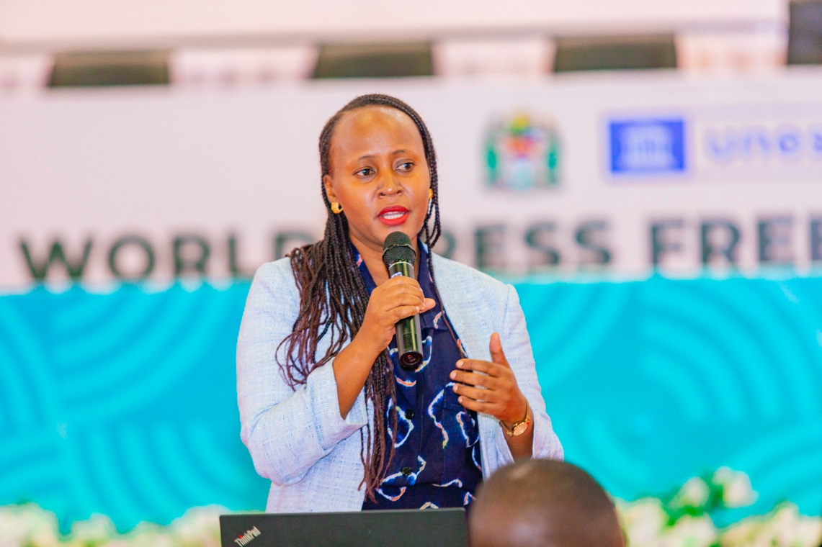
Ms. Fausta Musoka addressing the session on Media Future Scenario
2.6.3 The Picture of Now
In the first workshop the exercise apart from be informed by the resourcefulness of participants and their expertise from various media spectrum, also sought the community experience the way it consumes media content. The feedback, particularly from youth and small business owners, enriched the workshop as follows: -
1. Media is not considered significant and has no impact on their daily lives.
2. Media is primarily used by the powerful, with little coverage about ordinary people.
It was thus included that the picture of now portrays the image of Tanzania media as follows: -
- Media is broke;
- Lost public interest and trust;
- Not free, not independent;
- Struggling to keep up with technology;
- Failing women.
It was further enriched that the above scenario has been attributed to the following driving forces: -
- COVID-19 exacerbated existing financial struggles, leading to reduced advertising.
- Shift from traditional media to influencer accounts.
- Lack of investment in investigative journalism and public interest journalism.
- Over 63% of journalists lack permanent employment.
- Existence of Strategic newspapers.
- Repressive media laws.
- Challenges in journalist safety and security.
- Journalists are not free to report public interest stories and are willing to compromise.
- The Media Services Act has increased control but also professionalism.
2.6.4 The Media Driving Forces at Play
It was informed that the second workshop identified and analysed factors that could change the current state of media. These forces were seen as either help media to thrive or otherwise. Their relationship with media has been the factor that has shaped the outlook of Tanzanian media today. These forces are: -
1. Media relationship with Politics
2. Media ownership
3. Money
4. Quality of education
5. Audience behaviour
6.Technological changes and ability to leverage technology
7. Professionalism – issue of ethics and codes of conduct.

2.6.5 Envisioned Tanzania Media Scenario
The session was informed that the third workshop was conducted aimed at connecting the current state and these driving forces to imagine possible future scenarios that will characterise Tanzania media terrain in 2040. The participants were told that three scenarios were envisioned: -
- Scenario 1: Media in Crisis (Habari Kizungumkuti) 2024-2040.
The session was enriched by the insight from Entesh Malaisho (TWAWEZA), which entailed that media is envisioned to be in a mixed terrain, some will be free, others not free, some well-equipped, others not, some will continue to be irresponsible in their conduct. The forces that play role in this situation listed as follows: -
1. Journalism is primarily technology-driven, eliminating fake news and providing real-time, personalized information. However, this progress has introduced new challenges and disparities.
2. Technological benefits are unevenly distributed, with rural areas lacking access to electricity and the internet, worsening information inequality.
3. The population is mostly young, unhealthy, and poor due to economic hardships, including climate change, leading audiences to prefer relaxation and escapism over serious news.
4. Religious media houses thrive due to strong religious inclinations, while public interest media struggle under government restrictions.
5. Essential skills for journalism now include good equipment, tech savvies, training, and passion, replacing traditional journalism schools with a focus on empathy and technology.
6. The political climate is extremely polarized, with predictions of the most contentious elections in Tanzania's history.
7. Politicians use influencers over mainstream media to spread their agendas, and the government selectively targets media engaging in public interest reporting while avoiding conflicts with influential religious media.
8. Gender relations have improved significantly, with substantial funding for women empowerment and the rise of remote work enabling women to balance responsibilities and advance in their careers.
- Scenario 2: Troubled Media (Habari Kitanzini 2040)
The session was enriched by the understanding that the media will continue to be captured, continue to fail the public and be compromised. Presenting the IMS workshop insight, Sammy Awami said that the future projection informed that as time ticks, academic credentials will no longer matter; everyone sends and receives information. This situation is further informed by the empirical evidence as happened 10 years ago when authorities conducted an operation to suppress the media. He provided the time frame of future scenario as follows: -
Year 2033
1. The authorities built a practical training college camp in Mvomero. Skilled journalists who criticized the ruling party and the government were sent there. After being abducted, these journalists chose never to see their families again rather than disappear completely.

2. While at the college, they do not farm or cut firewood; their main job is to write news praising the party and the government. The camp has machines installed to broadcast live speeches and statements from leaders. The job of these journalists is to use these materials to write stories praising the party and the government.
3. Citizens on the outside see magazines that just appear, but they don't know where they come from, who the writers are, or where the news they write comes from.
Year 2025 to 2030
4. The media struggled; laws continued to be oppressive, and business was bad. The debts owed by the government for over 15 years were not paid but instead increased. These media outlets are afraid to demand payment from the government forcefully due to fear of further oppressive laws.
5. Operational costs doubled after Tanzania's economy faltered. For four consecutive years, heavy rainfall caused floods nationwide, bringing disasters. Agriculture died, wildlife reserves filled with water, gold mining pits flooded, and foreign aid ceased as well. Foreign aid ceased because those countries were busy with wars, and the United States was preparing for a Middle East war while China was preparing for a war with Taiwan.
Year 2031 to 2035
6. This is the year the media was in a stranglehold. The media opened the door for everyone with information to publish it anywhere. The audience got used to this situation, and all the information praised the government. Social media was filled with gossip.
7. In 2034, a group of 16 women emerged, working underground, especially using the cover of savings groups. Many of them were those who emerged rapidly in 2027, received training, and some became editors while others remained on the streets. While they were out, they received journalism training.
8. Due to professional pressure, there was no capability to publish newspapers or broadcast on radio and television. So, if someone wanted news, they would ask a chatbot, and after it finished, the information would be deleted. Strategies for distributing news in the regions were developed so that news could spread nationwide.
(C) Scenario 3: Media is Free (Habari Huru/Habari Inaendesha Dunia 2040)
This conceived scenario manifests in the media been free to fulfil its role as public watchdog, agender setter, agent of social change among others. A session was enriched by the insight of Dr. Baruani Mshale from TWAWEZA and following driving forces were enumerated as: -
- The media industry is free, strong, professional, and not driven by political or commercial interests.
- Journalists themselves uphold the principles of journalism, and if any of them deviate, they are held accountable by their existing professional associations.
- There is a diversity of media outlets with different ownership and perspectives, contributing to a variety of viewpoints in society because there is an entity that focuses on public interest.
- There is proper use of technology. Even if someone uses technology to distort information, the same networks can be used to verify the truth of that information.
- We have skilled individuals thanks to improvements in the education sector.
- We have robust legal and policy frameworks that protect the professionalism and freedom of the media sector.
- We have a discerning audience, many of whom are young people adept at using technology. They carefully choose what content to engage with and what to ignore. Even when laws or actions are taken that violate media freedom, the audience can take action. Recently, we have seen protests where people opposed legal amendments that would restrict media freedom.
- Political freedom. Due to economic changes that have occurred, the media sector is no longer dependent on politics. Politics is no longer in control; rather, the media is in control. Politicians have to align with what the media sector demands. The media sector now has the power to hold politicians accountable, unlike in the past.
The time lane on the scenario were set as follows: -

Year 2024-2030
- The media sector continued to be in a stranglehold, especially during the local government elections in 2024 and 2029, where there was no freedom at all.
- Media outlets that tried to provide equal coverage for candidates were shut down, and some had their licenses revoked.
- There were technological advancements, but many outlets struggled due to the cost, capability, and knowledge required using these technologies.
- There were efforts to promote gender equality, with many conferences held, and women started to take positions in newsrooms, but progress was slow and met with resistance.
- Inadequate legal systems persisted. Oppressive laws continued to exist, with occasional periods of freedom, but during elections, the situation was very bad. Politicians exploited the financial struggles of the media industry to coerce journalists into becoming their spokespersons.

Year 2031-2035
- The use of technology increased.
- Efforts to promote gender equality continued to spread and became a catalyst for change.
- There were administrative changes, and due to economic and political hardships, people grew tired and began to disregard the media. Media outlets lost credibility with the public and started to reflect on their roles.
- Citizens demanded content that would help them cope with climate change and the ongoing global economic downturn.
- Media outlets began to transform to regain credibility with the public and influence within society.
- During this period, democracy started to make a comeback globally. People became disillusioned with populist governance, which had been prevalent worldwide, and began to value democracy again. Even in Tanzania, citizens recognized the importance of democracy.
- Changes in the education sector, including curricula in universities, led to graduates with better expertise and skills suited to local conditions.
- Opportunities for practical training increased, resulting in confident journalists who understood the needs of their audience.
- Efforts to promote gender equality intensified. Democracy involved various groups coming together for discussions.
- New media outlets emerged, providing in-depth analysis and free from governmental interests.

The session was notified that the fourth workshop in scheduled in June which will gather feedback from stakeholders on the three scenarios, refining and completing them for publication and dissemination. It is anticipated that these scenarios will be used to stimulate discussions and strategy planning to avoid negative outcomes and promote positive changes for the media in Tanzania.
IMS plans to use these scenarios to engage parliamentarians, policymakers, and politicians. As Tanzania is the first to undertake this exercise, IMS hopes to implement this model in over 30 countries, promoting Tanzania’s leadership in the field.
2.6.6 Media Viability
The session was presented with issue of media viability by Dastan Kamanzi from Tanzania Media Foundation (TMF)
2.6.6.1 A Prism from TMF – by Dastan Kamanzi
It was informed that media viability is the ability of media outlets to produce high-quality journalism sustainably. According to the presentation, TMF focuses on internal media viability, including legal frameworks, governance, business, finance, technology, and content quality. Research indicates varying content quality levels, with notable gaps in public interest journalism, investigative journalism, and accountability.
What portrays current Media State
- Content quality was 27% in 2018, 22% in 2019, and 30% in 2022.
- High-quality journalism is lacking in Tanzania.
- 65% of journalists earn less than 500,000 TZS.
- A study of 234 journalists in 2023 found that in 13 years, they had only attended two seminars on public interest journalism.
- Journalists lack competence and internal media systems are weak. The nature of media ownership exacerbates these issues, resulting in low accountability, lack of transparency, increased injustices, human rights violations, and uninformed citizens.
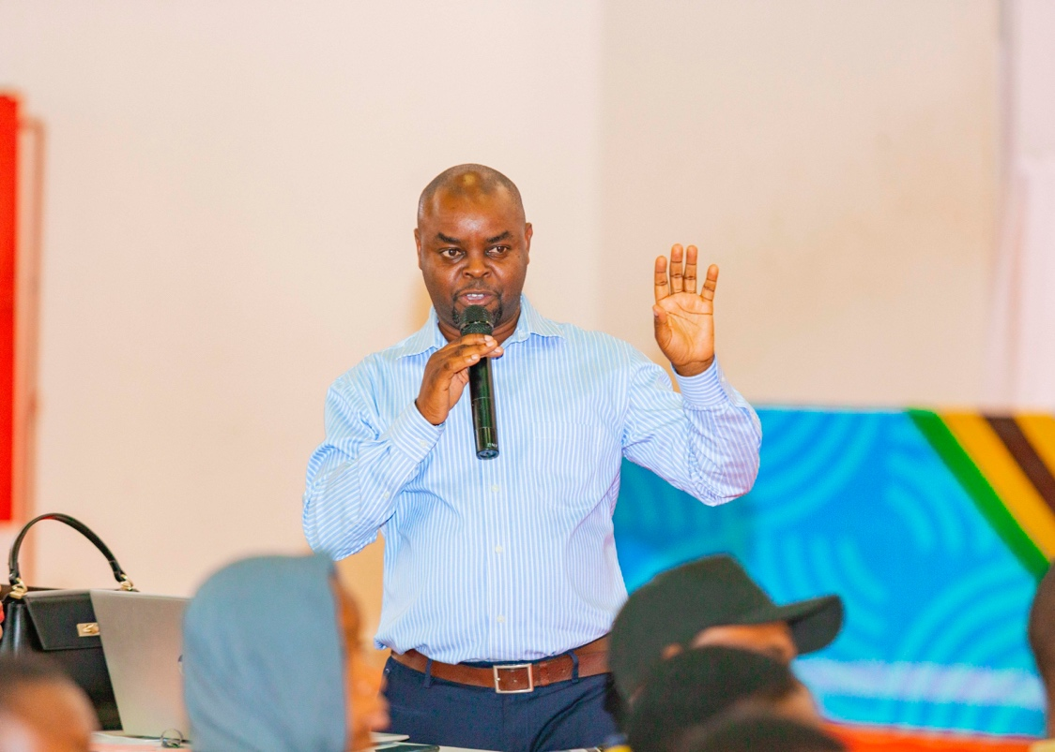
Dastan Kamanzi stressing elaborating an issue during Media Futures Session

2.6.6.2 Current State: A note from Nuzulack Dausen, NUKTA AFRIKA
From NUKTA Africa view point it was established that Tanzania media mirrors the following situation: -
- Low proficiency in modern journalism and communication skills among journalists.
- 44% of media outlets have never provided training and have no plans to do so.
- Journalists prefer training incentives over the actual knowledge gained.
- Innovation in product development is a challenge.
- Journalists believe fundraising is the management's responsibility.
- Journalists have stagnant job positions.
- Consumer behavior has shifted, with many no longer interested in news. Packaging news to engage consumers is crucial.
- Audiences prefer content that solves their problems.
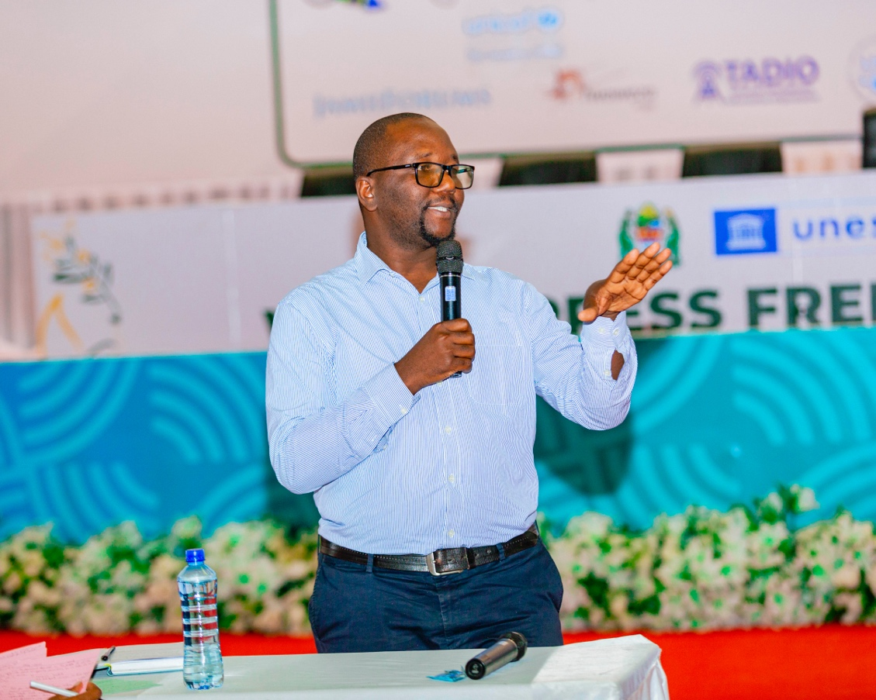
Nuzulack Dausen stressing a point during Media Futures Session
2.6.7 Challenges:
- Limited time allotted to the speakers, preventing the sharing of rich information.
- During the second session, many journalists, especially those from press clubs, moved to other rooms, resulting in fewer participants. This was critical because the session covered three important scenarios that needed their attention.
6.6.8 Lesson Learned:
To ensure effective communication and participation in future panels, it is essential to allocate sufficient time for each speaker and to find ways to keep journalists engaged throughout all sessions. This will help ensure that important information and scenarios are adequately addressed and discussed.
6.6.9 Resolutions:
- Journalists are advised to enhance their knowledge and skills continually to produce high-quality content.
- Media stakeholders have the responsibility to empower journalists with learning opportunities to create consumer-oriented content.
- Generating understanding among journalists and students from grassroots levels about the importance of obtaining accurate information, leading to the recognition of the significance and value of news in society.
- Media outlets should learn to adapt to technological changes. Journalists should adapt to their environments and prioritise the public interest over personal gains.
- Media stakeholders should devise strategies to rescue the media industry to avoid a crisis if no action is taken.
- Editors, UTPC, TADIO, TEF, MCT, and media regulators should be condemned due to unprofessionalism in the media.
- Organisers (IMS) should develop these three types of media futures scenarios by 2040 in movies/films to enhance public understanding.
- Journalism universities, in collaboration with the media sector, are advised to be knowledge hubs by equipping students with additional skills for sustainability.
- Journalists are encouraged to be multi-skilled and multi-talented rather than relying on one type of work.

2.7: Media and Child Rights

2.7.0 Introduction
The rights of children permeate various academic debates, movements, and the future of human advocacy regarding the position of this group. Unfortunately, the realisation of such rights relies on the compassion of others. This situation is exacerbated by the fact that children are among the vulnerable groups who cannot advocate for themselves. By recognising this reality, the international community and various nations have formulated conventions and laws to protect children's rights. Among these conventions is The United Nations Convention on the Rights of the Child (UNCRC). This convention establishes a legal framework for safeguarding children's rights. Prohibited within this convention is corporal punishment, as defined in articles 19, 28 (2), and 37, which broadly oppose all forms of physical or mental violence, injury or abuse, neglect or negligent treatment, maltreatment or exploitation, including sexual abuse. In the context of the commemoration of WPFD in 2024, special emphasis was placed on corporal punishment and its effects on child development. The debate also focused on alternative positive punishment methods. This entails implementing alternative disciplinary measures for children, especially within educational systems, particularly in school disciplinary procedures which promote and upholds child’s dignity which is fundamental in the development of one’s self-esteem.

2.7.1 Corporal Punishment against Child
The session was led by UNICEF and moderated by abled child right protection pioneer Usiah Nkoma, who briefly dwelled on the significance of discourse changes on the modes of child punishment in Tanzania. She invited the Panelists of the session, Evans Mori from UNICEF and Godfrey Beniventura from HakiElimu. The duo dealt in deep on the subject matter on why corporal punishment is not the best option in discipline the child.

Evans took the floor by alerting the participants that generally corporal punishment is often practiced with good intentions, but the fact is that it is the most common form of violence against children. He further adduced the universal definition of the corporal Punishment as defined by the Committee on the Rights of the Child as any punishment in which physical force is used and intended to cause some degree of pains or discomfort, however light. Most involves hitting, smacking, slapping, spanking children, with the hand or with an implement – a whip, stick, belt, shoe, wooden spoon etc.

He further expounded that UNCRC requires the prohibition by law and elimination in practice of all corporal punishment in all settings, in school environment, at home, in alternative care settings, day care and in penal systems. Specifically, he referred to Article 37 of UNCRC which provides that States Parties shall ensure that: No child shall be subjected to torture or other cruel, inhuman or degrading treatment or punishment.

2.7.2. Corporal Punishment in Schools – The Legal Framework
Despite the stand of the UNCRC, in Mainland Tanzania corporal punishment is lawful in schools, for boys and girls, under the National Education (Corporal Punishment) Regulations 1979 pursuant to section 60 of the National Education Act 1978. He emphasis that Regulation 3 states that corporal punishment “may be administered for serious breaches of school discipline or for grave offences committed whether inside or outside the school which are deemed by the school authority to have brought or are capable of bringing the school into disrepute”; the regulation put stress or a caution on the execution of the punishment as it states “It must be reasonable having regard to the gravity of the offence, age, sex and health of the pupils and shall not exceed four strokes on any occasion.” Evans explained that despite the cautionary observation on the regulation, there is enough evidence that many teachers disregard it. There are evidence of deaths, injuries and maimed children due to excessiveness of punishment by teachers.

2.7.3 The Consequential Effects of Corporal Punishment for Children
Corporal punishment carries multiple risks of harm and has no benefits. It violates children’s right to education, including by creating a violent and intimidating environment in which children are less able to learn. Corporal punishment in schools has been picked as one of contributing factors for children drop out of school, hence making them more vulnerable to other forms of exploitation.

Equally, there is empirical evidence that corporal punishment contributes to the poor performance of pupils in school as they become fearful of trying new things and become slower at learning social and academic skills. Failing to prohibit school-based violence ultimately promotes a low level of education and negatively impacts on social cohesion and development.

It was revealed that corporal punishment has long consequential negative effects on children’s cognitive development and education which may last into adulthood. In some studies, adults who experienced corporal punishment as children were less likely to graduate from college or to have high status and highly paid jobs.

7.2.4 What Needs to Change
- It was clear from the presentation that there is a need for concerted efforts for transforming school culture and protect children from corporal punishment. Such efforts should take cognisance of the law that permits corporal punishment and campaign for its reforms.
- Law reforms needs to be linked to awareness raising and promotion of positive, non-violent relationships with children.
- The campaign for law reforms should strive to illuminate in details how corporal punishment carries multiple harms and has no benefits to the children upbringing and self-esteem development. The following points were stressed: -
- Corporal punishment violates children’s rights to education including by creating a violating and intimidating environment in which children are less able to learn.
- Corporal punishment in schools is often why children drop out of school, making them more vulnerable to other forms of exploitation.
- Record poor school performances as they become fearful trying new things and become slower at learning social and academic skills.
- Failing to prohibit school-based violence ultimately promotes a low level of education and negatively impacts on social cohesion and development.
- The negative impact of corporal punishment on children’s cognitive development and education may last into adulthood in some students, adults experienced corporal punishment as children were less likely to graduate from the college or to have high status and high paid jobs.
2.7.5 The Good School Program
There has been various approach in bringing about changes to overhaul the punitive methodologies in school. In Africa many countries have made significant strides in eliminating all forms of corporal punishment in all settings. These include countries like South Africa, Tunisia, Zambia, Congo Brazzaville, Guinea, Benin and Kenya. Some have partially prohibited in some settings. Tanzania like Botswana, Somalia, Nigeria and Mali have not prohibited corporal punishment in any setting. In the East African Community, out of eight member states, it is only Tanzania and Somalia that have not made any step in prohibiting corporal punishment. Kenya and South Sudan are ahead of others by prohibiting corporal punishment in all settings.

2.7.6 A whole-school Approach
It was explained that a whole-school approach aims to change school operational culture by creating a safe and respectful school environment for children, free from violence. It strives to engage the whole school and surrounding community in a two-year process (teachers, administration, students and parents) to change ideas and attitudes around education. In so doing, it helps to improve teacher-student’s relationships and even supports change in behaviour around corporal punishment, students feel comfortable speaking up and fear teachers less. The program had transformed the school as teachers now tend to value positive discipline and the alternative discipline methods they learned from the program. Also, the support to the school administration increases transparent and accountability.

2.7.7 Alternative Discipline
Having learned and appreciated the new discipline dispensation, schools reflect on how violence manifests and establish a new school culture by exploring positive disciplinary methods to create students who believe in themselves.

The ultimate goal of this approach is to create students who believe in themselves and are thus motivated from within to be their best. In realising this, four suggestive categories were developed as a positive/alternative discipline practices that teachers could use: -

- Reflection (minor mistakes): Verbal warning, imposing time out, letter/essay writing on why they misbehaved, oral apology;
- Penalty (Repeated mistakes): physical work i.e., slashing the grass, cleaning the school, community service, Withdrawal of privileges i.e., not playing school games, Additional time at school (detention);
- Reparation: Public apology i.e., school assembly, involving parents, financial restriction, child contributes towards replacing or repairing any damaged school property;
- Last resort (Persistent and serious offence): referral, time-limited suspension, a recommendation for the expulsion of school

2.7.8 What Role the Media Can Play?
Media is the cornerstone agent of a change. Transforming law and behaviour patterns of a particular society needs collective efforts to pull together all relevant stakeholders, firstly, to buying in to the idea, but more importantly, to play active role for such changes to be realised. It is in such context media has to play a pivotal role as follows: -
- Raise awareness – produce and disseminate informative content highlighting the adverse effects of corporal punishment on children’s physical and psychological well-being;
- Increase coverage – provide balanced and comprehensive coverage of advocacy initiatives to end corporal punishment, including interviews with experts, affected individuals and policymakers;
- Promote alternatives – Feature positive examples of schools, communities and families implementing non-violence disciplinary methods, showing their effectiveness and feasibility;
- Generate positive dialogue – Facilitate discussions and debates on media platforms to engage the public, particularly, experts and influential community members, in conversations about the need to shift societal norms away from corporal punishment.

2.7.9 Empirical Evidence of Corporal Punishment
The second panelist Godfrey Beniventura, an expert of right to education from HakiElimu, took the floor and he presented some disturbing findings regarding corporal punishment effect against school children. HakiElimu has been doing turning around program under the name Good School Tool Kit (GST) aims at creating violent-free learning environment in schools.
Figure # 1

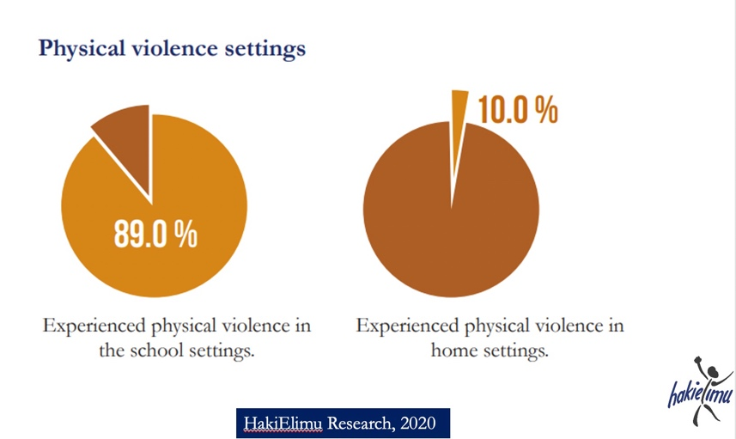

It was self-evident from HakiElimu Research Report 2020 that the corporal punishment has caused physical violence against school children. The reports reveled that 87.9% of school children experienced physical violence in school setting, while other 10% experienced physical violence in home setting. 90% admitted to have been canned which also constitutes another form of physical violence. According to HakiElimu findings the physical violence against school children has become habitual and perpetual in their daily school life in both rural and urban school settings. For instance, 37.1% experienced daily caning by teachers in school in rural settings, while 16.3% experienced daily caning by teachers in school in urban settings.

2.7.9 Children Bitter Testimonies
HakiElimu shared some painful experiences from children (students) who have encountered corporal punishment as follows: -

Child # 1: “Nikichapwa viboko napata maumivu makali na inanifanya nisiwe na utulivu darasani, sitamuelewa mwalimu kabisa.” This can be translated as: “When I am beaten with canes, I feel severe pain and it makes me unable to be calm in class, I will not be able at all to follow what the teacher is teaching.”

Child # 2: “Viboko vinafanya tuwaogope walimu na kushindwa kuomba msaada unapohitaji.” This can be translated as: "Caning makes us fear teachers and fail to ask for help when we need it.”

Child # 3: “Siwapendi walimu wanaotumia Viboko.” This can be translated as:
“I don't like teachers who use canes."

These testimonies attest the general understanding that corporal punishment is of no positive benefits for both academic and self-esteem development of the children. Overtime, experts have developed steps to be followed in both social and school settings to accommodate positive alternative punishment. Such steps among others, require availability of the competent teachers, good and safe environment for schooling and good leadership.

HakiElimu in its endeavour in solving huddles on the rights to education for children conducted a pilot project program which involved eight schools in Tanzania. The overall objective of the project was to see the transition from negative corporal punishment to positive alternative punishment in both society and school setting. The listed step by step procedures included the formation of implementing team; Preparation of the society for a change; Training; Preparation of teachers; To build a society that embraces the culture of alternative positive punishment; Improvement of school environment and improvement of the administration and leadership.

Figure # 2
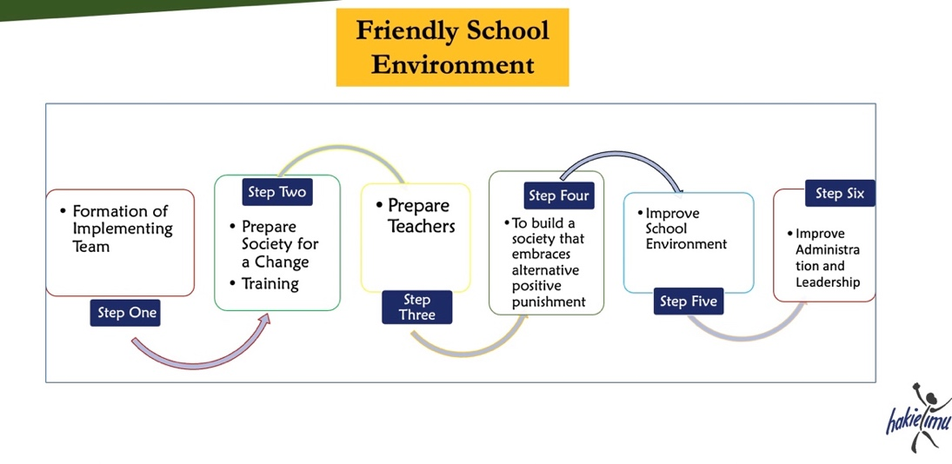
HakiElimu 2024 Evaluation Report findings from this pilot project in eight schools reveled tremendous transformation of disciplinary approach within school. The findings include students feeling safer, teachers becoming more friendly and significant decline of violent physical punishment in school settings.

Figure # 3
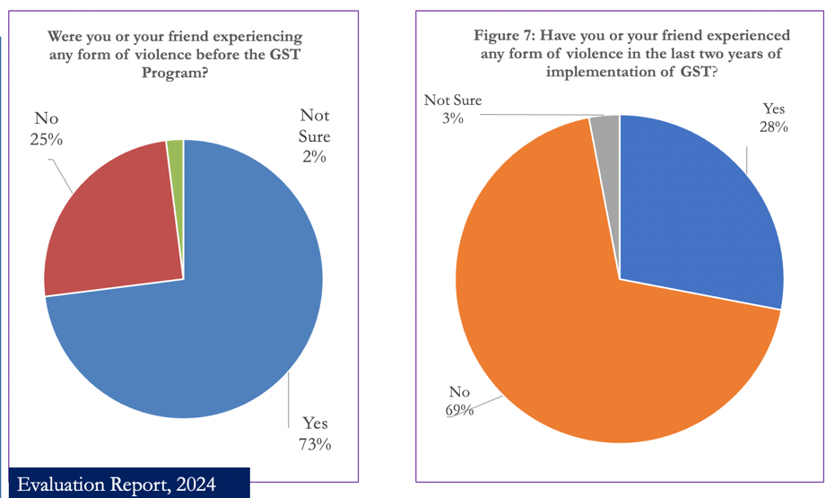
Figure 3 above show a tremendous impact of GST in transforming the society from negative physical punishment measures against children to positive alternative punishment. HakiElimu 2024 Evaluation Report revealed that 73% of the students who were interviewed admitted that either themselves or their friends had experienced some form of physical violence before the implementation of GST; however, the trend seems to have taken an opposite trajectory with the implementation of the program. When asked the same question during two years of the implementation of the GST, 69% of the student said they have not experienced the physical violence.

Figure # 4
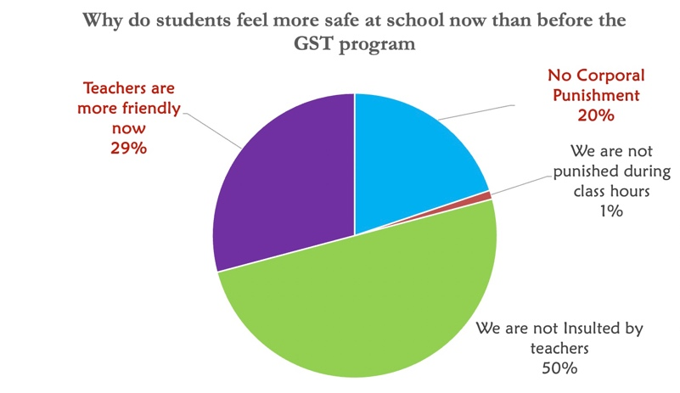

Overall picture revealed that 99% of the students were safer now than before the implementation of GST program in the eight schools project was been implemented. Farther interrogation of the reasons for being safer revealed even some interesting findings. Figure # 4 is a self-explanatory, 29% of students said their teachers were more friendly, while 50% said that insults from teachers is a matter of past as they were no longer receiving insults from their teachers. 20% of the student said that no more corporal punishment, with only 1% of the students admitting to have been punished during class hours.

Figure # 5
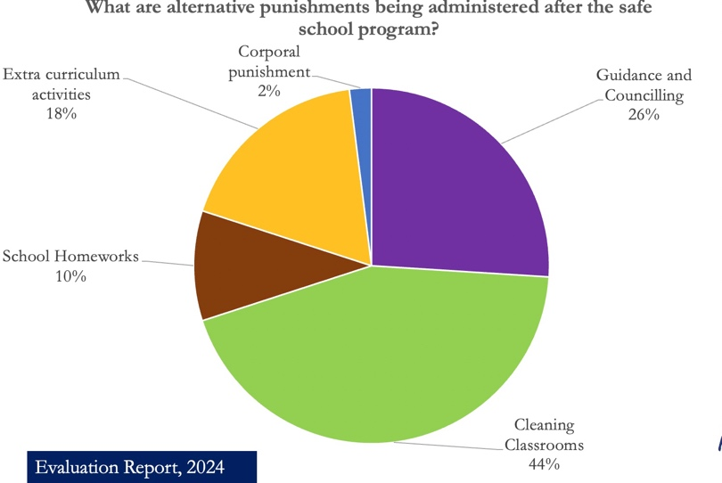

Farther more, the HakiElimu 2024 Evaluation Report on the GST program helps to paint an interesting picture of the transition from negative physical punishment to positive alternative punishment. The report established that with GST program in place, different types of punishment were used including 18% doing extra curriculum activities; 2% receiving corporal punishment; 26% committed to guidance and counselling, 44% were asked to clean classrooms; while 10% were given school homework.

While concluding his presentation, Godfrey asked society to candidly interrogate its approach towards cultural norms and values on the appropriateness of the punishment befits our children. Also, society need to critically ask if we can teach students and they understand the lessons, why don't we teach them the consequences of their mistakes? More so, we need to ask ourselves that do we think the use of canes helps a student to have discipline? To be in students’ shoes one can ask himself or herself that if he or she make a mistake, is he/she ready to be caned by his or her employer? Finally, it is imperative for one to do a self-reflection by asking when he/she was a student and if he/she was ever caned, what kind of feeling did one get? Such self-interrogation can help the society to start thinking about changes in the way violent physical punishment have been unleashed to children resulting into detrimental negative consequences some lasting to their adulthood.

2.7.10 Discussion and Contributions from the Floor
It was suggested that there is a need to adopt a system of keeping records of every student/pupil for better monitoring their development and avoid accidents. It was further observed that Tanzanian curriculum system is not friendly to the upbringing of the children, there is a need to overhaul them to do away with corporal punishment in all school settings. Contributing on the curriculum overhaul, veteran media personnel, Theophil Makunga, advised the changes should also include teachers’ training curriculum to build in them issues of alternative punishment. He recalled that while teachers’ training requires them to use corporal punishment in a way friendly way, now days is used as a means not only to inflict pains to students but also in a sadistic way.

An advocate Mwita was of the opinion that to solve the puzzle of child abuse, a total turnaround transformation has to be considered from family level, at social setting to the school environment. She was of the opinion that marital conflict amongst couples breeds enraged parents who are prone to child abuse act, whether as parents, guardians or teachers. The is a need of setting up a system that offers psychosocial counselling in schools to help teachers who seems to be in challenging state of life. Teachers are thus the byproduct of out environment and setting, any change to be effective it has to have a holistic approach from the family level to workplace.

A senior journalist Lyaruu (Manayara) was of the opinion that while campaign for the reform of the law that provide room for corporal punishment is imperative to end child abuse, he stressed role of the family in the up bring of the children. He was saddened by the current trends of many couples who have abdicate their parenting role to the society. He underscored that every family should be accountable in the up bring of their children. Quite often, many parents have abdicated their pivotal role in the entire process of child education process.

Jane Mihanji a veteran journalist challenged the society to interrogate the genesis of corporal punishment. She posed pertinent question on whether corporal punishment was part of African traditional ways of upbringing and teaching. She suggested that teachers should made to understand the negative effects are causing to students through corporal punishment. Families must be steadfast in the appropriate parenting to their children.

Dr Rose Reuben a veteran journalist and Tamwa director she was taken aback by the fact that Tanzania is yet to have family policy, which she sees as having connection with trend of child abuse. Absence of such crucial policy document can be cited as one of the contributing factors toward bad parenting. We need to push for the preparation of such policy as it may significantly have some mitigating measures on parenting at family level and generally in the society. She as well urge media fraternity to increase engagement and networking to demand for the reform of the laws that advocate for corporal punishment.

Saggaf a journalist from Maelezo was quite instrumental in his contribution by asserting that corporal punishment is a foreign system of punishment imposed on African societies. He made a special reference to our religions that do not condone violence. According to Quran, the process of child upbringing is divided into three phase of seven years each. The first seven years is the process of instilling love in a child. The second seven years is devoted to implant in child obedience behaviour; and the third seven years is the stage of implanting to a child an obedience with reasoning. He concluded that in all of these stages there is nowhere corporal punishment constitutes ethos of upbringing. He urged media to advocate for the traditional methods of punishment which were appropriate and humane.

Neville Meena a senior journalist who have been in interest on number of campaigns about child rights, insisted the need of a serious campaign to undo the ill narrative that it is impossible for a child to be disciplined without corporal punishment (caning).

Media need to be trained so that can have a common understanding about the negative impact of violent physical punishment, in particularly corporal punishment. This can be achieved through some concerted efforts to write stories that will influence changes in law and policies that condone violent physical punishment in school and within our society.

Chapter Three: Resolution

RESOLUTIONS OF JOURNALISTS AND MEDIA STAKEHOLDERS IN TANZANIA DURING THE 2024 WORLD PRESS FREEDOM DAY CELEBRATIONS

3.0 NTRODUCTION
We, the journalists and media stakeholders of Tanzania who participated in the 31st World Press Freedom Day celebrations in Dodoma on May 2-3, 2024, discussed various issues concerning the media industry in the following areas:
1. Strategic Dialogue: Journalism for Development
2. Legal, Policy, and Working Environment
3. Media and Gender Issues
4. The Future of the Media Industry
5. Protection and Security of Journalists
6. Media, Artificial Intelligence, and Technological Development
7. Media and Child Rights

That, unanimously we have resolved the following to be considered for the betterment of the media sector in the country:

3.1 TO THE GOVERNMENT:
(a) The government should continue to create a friendly and safe environment for the media to operate freely.
(b) The government should increase transparency in its operations to promote accountability.
(c) The government should enforce labour laws to protect the rights of workers in the media sector.
(d) The government should develop a national policy on the use of Artificial Intelligence to ensure its optimal use.
(e) The government should amend the Statistics Law to remove obstacles against investigative journalism (IJ).
(f) The government should continue to review the Media Services Act to remove sections that hinder freedom of the press.
(g) The government should review the teacher training curriculum to build awareness of the harms of corporal punishment and the benefits of alternative disciplinary methods for children.
(h) The government should review laws, regulations, and guidelines on corporal punishment to establish an alternative punishment system in the country.

3.2 TO THE PARLIAMENT:
Parliament should allocate sufficient time to receive and hear stakeholders' opinions during the process of drafting or amending various laws, including those affecting the media sector.

3.3 TO MEDIA INSTITUTIONS AND STAKEHOLDERS:
(a) Media institutions, in collaboration with the police, should develop a special strategy for the protection and security of journalists ahead of the elections.
(b) Media institutions and stakeholders should collaborate to prepare a national plan of action for the safety of journalists in Tanzania.
(c) Discussions on the protection and security of journalists should be expanded to include other stakeholders such as political parties, government leaders, and media owners to strengthen their safety.
(d) Media institutions should continue to educate journalists on media laws and build their capacity for physical and digital security.
(e) Media institutions should collaborate with climate change experts to assist in the preparation of content with accurate messages for the public.

3.4 TO THE MEDIA OUTLETS:
(a) Media outlets and journalists should adhere to the ethics and codes of journalism during the run-up to the general elections.
(b) Media outlets, in collaboration with various stakeholders in the country, should invest resources in money, skills, knowledge, and tools to develop journalists specialised in climate change reporting.
(c) Media outlets should develop business strategies that consider the use and development of digital technology in the media industry.
(d) Media outlets using Artificial Intelligence (AI) to produce content should ensure transparency (attribution) for their audience (consumers).
(e) Media outlets should build the capacity of journalists and content producers to use Artificial Intelligence.
(f) Media outlets should invest in digital technologies to control false, inaccurate, and misleading information.
(g) Media outlets should enhance strategies for reporting on sustainable development goals (SDGs) for the welfare of the country.

3.5 TO JOURNALISTS:
(a) Journalists should continue to adhere to their professional ethics even amidst technological, economic, political, and social changes.
(b) Journalists should report incidents of distress so they can be assisted.
(c) Climate change reporting should consider the gender context to highlight its opportunities and impacts on women, children, people with disabilities, and those with special needs.
(d) Journalists should enhance their knowledge and skills to produce quality content.
(e) Journalists and media institutions should unite to have a collective voice in fighting for journalists' rights.
(f) Journalists should be trained on the impacts of corporal punishment on children's welfare.
(g) Journalists should write stories that persuade society to recognise the harms of corporal punishment against children to change the perspective on this punishment.

3.6 TO JOURNALISM EDUCATION INSTITUTIONS:
(a) Journalism training institutions in the country should introduce short courses that will build journalists' understanding and proper education on climate change and journalistic techniques for reporting these issues accurately and in-depth.
(b) Journalism schools should increase student participation in media and communication conferences to build knowledge that is not acquired in colleges.

3.7 TO DEVELOPMENT PARTNERS:
Development partners should continue to allocate financial resources to enable various media programs such as training to combat corporal punishment, safety of journalists, election reporting, climate change journalism, and understanding of the Sustainable Development Goals (SDGs).

Chapter Four

Additional matters

4.0 Memorable Moment: Fun Run
The curtain-raiser event of the National Conference of WPFD 2024 took place on the 1st of May 2024. The event was graced by Hon. Jabir Shekimweri, the District Commissioner of Dodoma. The main event was the Media Run for Fun. In his speech, the DC urged the media houses, organizations, and media practitioners in the country to build and instill a culture of doing exercises as the preventive measures against unwarranted diseases and be healthy. Hon. Shekimweri further called upon media practitioners to use their pens to promote environmental conservation “As a country we are losing around 400,0000 acres of forests a year due to man-caused environmental destruction. You journalists and media should be the agents of change by raising awareness and educating the citizens on environmental preservation and protection,” the DC urged.

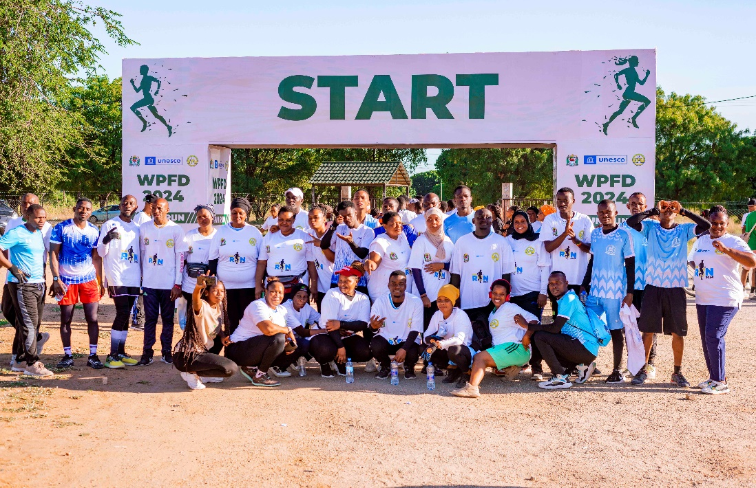

A section of runners of Media Run for Fun pose for a group photo to mark the start of the 10km run in Dodoma
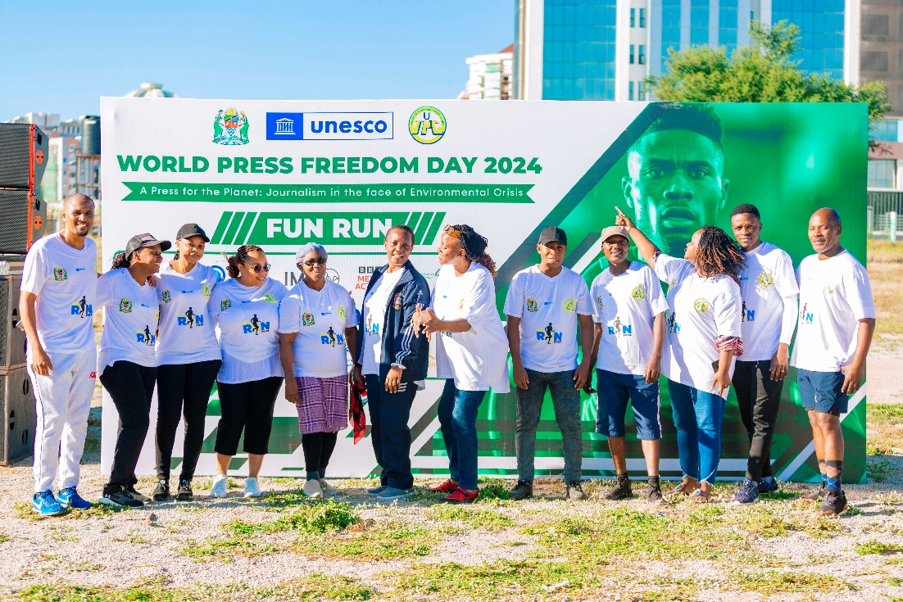

A Section of participants of 10km Media Run representing diverse media stakeholders

Hon. Shekimweri appreciated the efforts of regreening the country led by Her Excellence Dr. Samia Suluhu Hassan the President of the United Republic of Tanzania. He cited Dodoma as an exemplary of such efforts which saw the city which was once a semi-arid region now turned green as a result of trees planting and preservation initiatives.

  - Media Run for Fun
The concept behind the Media Run was to raise environmental consciousness among media stakeholders and the community at large to have a shared commitment to a sustainable environmental protection. The Media Run communicated the message of unity and hope while calling for environmental responsibility for a greener and healthier planet.
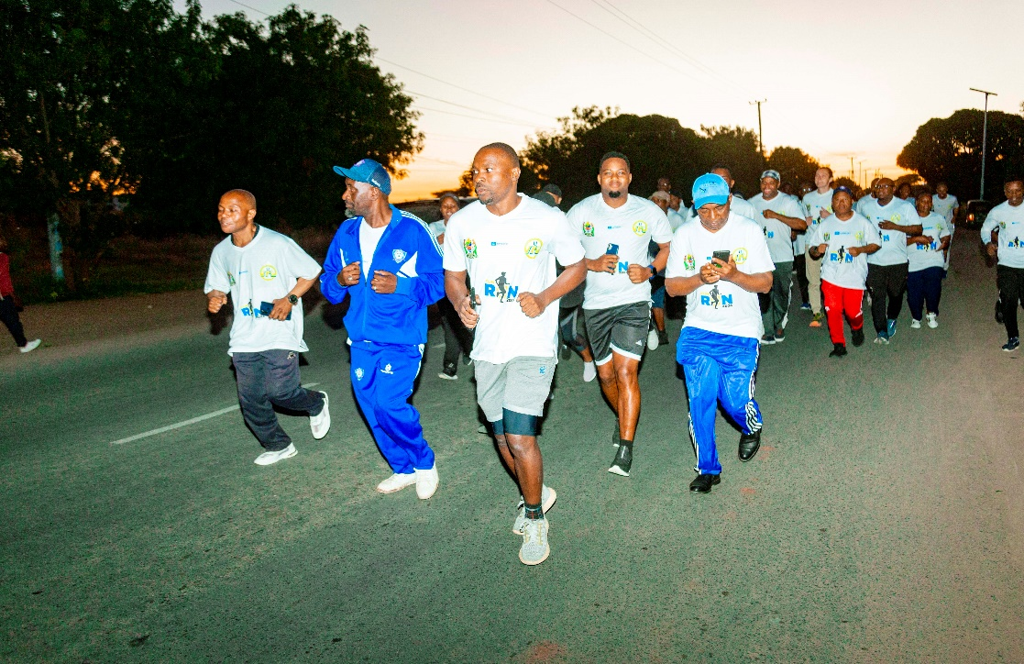

Hon. Jabir Shekimweri Dodoma DC (in red & white) was among the participants of the 10km Media Run event.

The Media Run registered runners from media houses and organizations, State and Non-state media actors, implementing partners, and the general public. The 10km Fun Run commenced at 5 am and was completed around 7 am at the Jakaya Kikwete Conference Centre.

